Oil spill response in/and around the North-west European ports

Final report

Authors: Valentin Carlan, Trevor Heaver, Christa Sys, Thierry Vanelslander

V4/11.11.2016

Imprint

Principal:
ClearSeas, 630 - 355 Burrard St., Vancouver, British Columbia, V6C 2GB

Executed by:
University of Antwerp, Department of Transport and Regional Economics, Prinsstraat 13, 2000 Antwerp, Belgium

Authors:
Valentin Carlan, Trevor Heaver, Christa Sys, Thierry Vanelslander

Cite:
Carlan, V., Heaver, T., Sys, C., Vanelslander T. (2016) Oil spill response in/and around the North-west European ports – Final Report, University of Antwerp

Published in Antwerp, 2016
This report on the study of “Oil spill response of authorities in and around North-West European ports was prepared by the department of Transport and Regional Economics and is part of a research agreement between University of Antwerp, Belgium and University of British Columbia, Canada.

Table of Content
List of Figures 5
List of Tables 6
1. Introduction 7
2. Method 10
3. Framework of Global/European pollution response agreements 11
4. Oil spill response in ports (collection of cases studies) 17
4.1. Oil spill response of Belgian authorities in/around the port of Antwerp 17
4.1.1. National organizational framework (the case of emergency interventions) 17
4.1.1.1. Disciplines involved in emergency response actions 19
4.1.1.2. Emergency intervention at sea 20
4.1.1.3. Emergency interventions on land (the area around port of Antwerp) 20
4.1.2. Oil spill response in the port of Antwerp 21
4.1.2.1. Notification/oil spill response structure 22
4.1.2.2. Financial responsibility and cleaning costs recovery flow chart 24
4.1.2.3. Prevention actions 25
4.1.2.4. Media communication 25
4.1.2.5. Level of preparedness (equipment) 26
4.1.2.5.1. Level of preparedness of private contractor 26
4.1.2.5.2. Level of preparedness of public authorities 27
4.1.2.6. Level of preparedness (training / evaluation procedures) 28
4.2. Oil spill response of Dutch authorities in/around the port of Rotterdam 29
4.2.1. National organizational framework (the case of emergency interventions) 29
4.2.1.1. Emergency intervention at sea 31
4.2.1.2. Emergency interventions on land (Example the port of Rotterdam) 32
4.2.2. Oil spill response in the port of Rotterdam 33
4.2.2.1. Notification/oil spill response structure 34
4.2.2.2. Financial responsibility and cleaning costs recovery flow chart 36
4.2.2.3. Prevention actions 37
4.2.2.4. Media communication 38
4.2.2.5. Level of preparedness (equipment) 38
4.2.2.5.1. Intervention equipment of HEBO 38
4.2.2.5.2. Intervention equipment of Rijkswaterstaat 40
4.2.2.5.3. Intervention equipment of Schermenpool 40
4.2.2.5.4. Intervention equipment of the fire brigade 41
4.2.2.6. Level of preparedness (training / evaluation procedures) 42
5. Critical comparison of organization matters with regard to oil spills 43
6. Best-practices and lessons learned 47
7. Final conclusions/recommendations 49

List of Figures
Figure 1. Evolution of large (>700 tonnes) oil spill. 8
Figure 2. EMSA contracted oil spill response vessels. 13
Figure 3. International frameworks for managing marine pollution. 14
Figure 4. Area covered by the Bonn agreement. 15
Figure 5. Belgian exclusive economic zone and territorial sea. 18
Figure 6. General emergency response scheme and responsible coordination. 19
Figure 7. Intervention disciplines to be activated in case of emergency situations. 19
Figure 8. Vessels prepare to respond to oil spill at sea. 20
Figure 9. Areas of responsibility in case of oil spill in and around port of Antwerp. 21
Figure 10. Oil spill response flow-chart in the port of Antwerp. 23
Figure 11. Financial flow of oil spill cleaning intervention at the port of Antwerp. 24
Figure 12. Location of oil spill intervention vessels in the port of Antwerp. 27
Figure 13. Dutch exclusive economic area and territorial sea. 30
Figure 14. Vessels prepare to respond to oil spill at sea. 31
Figure 15. Area of responsibility in case of oil spills occurring in and around the port of Rotterdam. 32
Figure 16. Oil spill response procedure in the port of Rotterdam. 35
Figure 17. Cleaning cost recovery flow in case of oil spill in the port of Rotterdam 37
Figure 18. Location of oil spill response vessels in the port of Rotterdam. 39
Figure 19. Launch location of oil spill protective equipment managed by Schermenpool. 41
Figure 20. Location of GB’s barracks in the port of Rotterdam. 41

List of Tables
Table 1. Oil spill categories according to spill amount. 8
Table 2. Global maritime conventions for environmental protection. 12
Table 3. European regional agreements with regard to oil pollution. 14
Table 4. Stakeholders involved in the oil spill response procedures at the port of Antwerp. 22
Table 5. Categories of oil spill present at the port of Antwerp. 24
Table 6. Overview of training followed by intervention personnel. 28
Table 7. Organizations involved in oil spill response in the port of Rotterdam. 34
Table 8. HEBO oil spill response vessels present in the port of Rotterdam. 39
Table 9. HEBO oil spill intervention material. 39
Table 10. SRH oil containment and cleaning equipment 40
Table 11. Comparison of oil spill notification/ response structure in ports 43
Table 12. Comparison of financial responsibility and cleaning costs recovery 44
Table 13. Comparison of oil spill prevention actions 44
Table 14. Comparison of communication responsibility aspects. 45
Table 15. Comparison of level of preparedness. 45
Table 16. Lessons learned from the experience of oil spill response experts 47
Table 17. Lifetime of equipment used in oil spill response. 48
Table 18. Best-practices to improve the oil spill response. 48

Introduction
This report is part of research initiated by the Centre for Transportation Studies at the University of British Columbia, Vancouver, Canada in collaboration with universities in Antwerp and Hamburg. The project is an examination of leading systems for oil spill response in ports.
Ports are confronted with different pollution sources such as waste, dust, noise, air pollutants or oil spills. Although, the awareness among port users with regard to environmental protection has increased, accidents with oil pollution still happen. To this matter, both public and private authorities have developed own oil spill prevention and response plans.
The response to spills raised the uncertainty of the public with regards to which agency is responsible in the eventuality of emergency events and whether the response to the spills could have been better. Two features of oil spill response lead to this research. First, a short overview of oil spill response illustrates that there are highly complex interests and responsibilities of numerous public or private agencies. Equally, these agencies are integrated into a response regime. Effective governance is at the core of effective response. Second, since the challenges are likely largely comparable in all ports, the question arises how are the governance aspects of spill response managed in the ports of other countries? Are there ports recognised as exemplifying best practice in spill response?
The purposes of this study are to examine the nature of governance issues affecting spill response in ports and to examine the systems used to achieve effective response in leading ports. In particular, the goal of the research is twofold. Firstly, it puts forward the organisation structures and operating practices to achieve leading spill response outcomes. And secondly, it identifies the lessons and best-practices to advance the effectiveness of spill response
Port users such as ship owners, especially ship tankers operators, have procedures and are prepared to handle oil spill situations from their notification till the cleaning procedure and oil spill cleaning costs. In the situation that a captain calls in to the ship-owner with an oil spill issue, an emergency response team is immediately assembled to handle the situation. The emergency team has representatives from different departments to provide support in all areas of expertize technical, quality, legal, commercial, crewing and communication. Nonetheless, in the eventuality of an oil spill, the ship owners rely mostly and depend on the cleaning capacities of port authorities and/or public agencies.
Researchers have covered the topic of oil spill by conducting mostly literature reviews on international, national and regional manuals and policy documents. There is also a substantial literature in conference proceedings and journals. Equally, research studies mention the necessity of response procedures to be followed when an (oil) spill is detected. Among others, Bergueiro, Oliver, González and García (2007) remark that when a spill occurs in the sea, it is essential to know the swell, the meteorological conditions and the marine currents, which make changes in the physical properties of the spilt. As well, Bergueiro, March, González and Socías (2007) note that spills modelling got a spectacular advance and several programs have been developed that allows the simulation of spills characteristics. These tools allow predicting a series of outputs related to spills trajectory, the minimum impact line and the impact point of the spills.
This leads to the question of how port communities (meaning all the stakeholders) use of these outcomes and whether they are able to effectively achieve their goals. The particular approaches to spill response vary among countries and ports. Case studies of ports in leading countries can serve to identify the implications of different organisational structures for the various agencies and provide evidence of best practices.

Spills in coastal and port areas usually characterized according to the following elements: the type of spill (continuous or discontinuous); cause; quantity of spilt pollutant and area affected by the spilt.
According to the cause, ITOPF (2015) differentiate between the following: oil spills caused by a allision/collision; grounding; hull failure, equipment failure, fire or unknown source. According to ITOPF reports, most oil spills which took place in inland or inside ports have happened due to grounding or allision/collision. ITOPF (2015) points as well that equipment failure is one of the most frequent causes of spills during discharging/charging operations.
The area which might be the subject of oil spills is an important element in the prevention and preparedness activity. Different technical equipment is deployed in case of oil spills depending on the affected area.
ITOPF (2015) also categories the oil spills by size. They record the oil spills caused from tankers, carriers and barges. Table 1 shows the three categories put forward by ITOPF. They remark that the vast majority of spills (81%) falls into the category of small spills for which reliable reporting is often difficult to achieve.
Table 1. Oil spill categories according to spill amount.
Oil spill size | Amount of spill
Large | >700 tonnes (>5,000 bbls)
Medium | 7-700 tonnes (50-5,000 bbls)
Small | <7 tonnes (<50 bbls)
Source: ITOPF (2015)
The evolution of large oil spill since 1970 is presented in figure 1.
Figure 1. Evolution of large (>700 tonnes) oil spill.
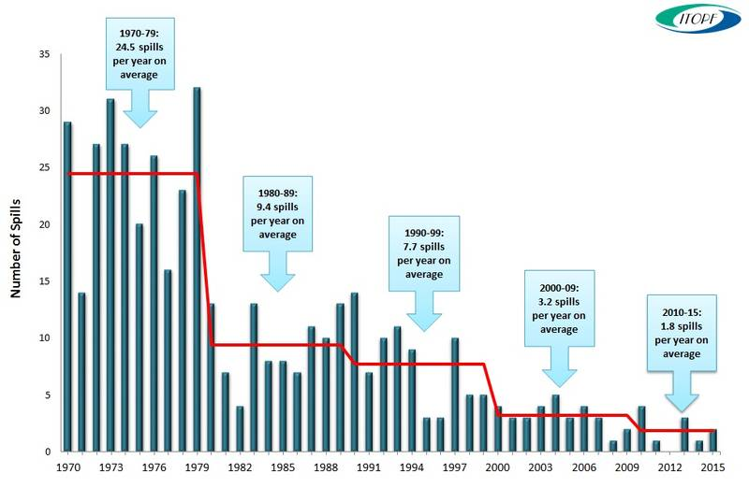
Source: ITOPF (2015)
As seen from the overview by ITOPF (2015) in figure 1, the number of large oil spills has substantially decreased during the past years. While in the 80’s and 90’s there was an average of 9.4 and 7.4 spills respectively per year, in the recent decade, it lowered to 3.2 oil spills per year. In Europe, few large oil spills have occurred since 1990. Here is to be mentioned the oil spill caused by TORREY CANYON (1967), AMOCO CADIZ (1978), MT HAVEN (1991), BREAR (1993) and SEA EMPRESS (1996).
Although on a descending trend oil spill still remains a threat for water pollution. The intensification of oil and gas related activities increase the probability of incidents that could lead to oil spill (EMSA, 2014). Hence, the oil spill response in and around ports remains a debatable issue.
The structure of the report is as follows. Section 2 summarises the method used to develop the report. Section 3 gives an overview of the agreements and conventions that have been established at European/global level against pollution with a view on oil spills. Section 4 details the organizational structures in case oil spills are reported in ports. This section discusses the role of different authorities responsible for intervention to oil spills. Moreover, it puts forward the organizational issues, the preparedness level and the exercises scheduled by authorities responsible to intervene on spills that occur in ports. Section 5 develops a comparison among the studied ports to point out the main differences and similarities between oil spill response practices. Lessons and best practices are then discussed in section 6. Section 7 puts forward the final conclusions and recommendation.

Method
To achieve the objectives of this research, first, an in depth desk research was conducted. The purpose of this research is to present the legal international framework under which the oil spill response is treated. Furthermore, by conducting interviews with experts on the theme of oil spill, details regarding the issues encountered by both authorities and port users were researched. This approach verifies whether an overall consensus regarding the pollution mitigation actions exits or whether port authorities have different approaches to prevent, plan and act in case of oil spill. Equally, a comprehensive framework for studying the authorities’ response in case of oil spills in and around ports was pursued.
In this regard, semi-structured interviews with experts in oil spill response from Western-European ports were conducted. The list of questions is presented in Annex B. The interviews consist of two parts corresponding with the research goals. The two sections of the interview are in close link with the research goals. The first part enquires about the role and the processes of one’s organization with regard to oil spill response plans and preparedness. It deals with the wide range of activities which may be required to be taken in the event of an oil spill. The second part collects information related to lessons and best-practices for an effective oil spill response.
The interviews conducted in the framework of oil spill research targeted to combine the view on oil spills of all level of authorities. In this regard, national, regional and local authorities with intervention responsibilities in case of oil spills have been contacted here are to be mentioned, experts from the Ministry, regional emergency intervention planning, municipality or port authority. Moreover, public and private institutions that could be involved in oil spill interventions in and around ports were interviewed. Hence, representative of the harbour master, civil protection, local police and specialized oil cleaning company were interviewed. The length of interviews depended on the role of the organisation in spill response and varied between 45 minutes to 2 hours. The list of companies’ representatives that participated in interviews is presented in Annex A.

Framework of Global/European pollution response agreements
This section puts forward an overview of legal framework and collaboration agreements on pollution/oil spill response issues. Oil spills are local problems with global repercussions. A short overview of international and regional conventions shows that oil spills are treated as pollution issues. In a society that gives preference to more environment friendly activities to be pursued, oil spills are events that are drastically amended and condemned. An overview of international conventions from IMO or European level is presented. Lastly, attention is also given to local agreements between authorities in North-Western Europe responsible for coordinating the response to small oil spills.
A number of international conventions have been adopted during the last decades in the maritime environment in regard to environmental protection issues. The following table gives an overview of these international conventions. This overview shows that a significant amount of treaties under which the issue of oil spills are handled have been set into force.
Table 2 shows the global conventions that addresses the environmental issues. A difference has been made between conventions that prevent the pollution and the ones that cover the liability compensation. It is noticeable that oil pollution has benefited from a lot of attention both in prevention matters but also in case of liabilities issues. The most important convention in case of legal liability for oil spills are CLC, LLMC and BUNKER. The first two set the limits the ship owners’ liability in case of maritime pollution damages caused by cargo. The later, treats the similar issue but from the perspective of oil pollution from a bunkering source.
The International Maritime Organization (IMO) has made efforts to develop further measures to prevent pollutions from ships. Their effort dates back in the 1970s when the concern for oil dumping was at its height and the MARPOL convention began to be globally ratified. Moreover in 1989 a conference of leading industrial national was called in Paris. Following that event, the IMO Assembly began a draft of a convention that provides a global framework for international cooperation in combating major incidents or threat of maritime pollution with the title ‘Oil Pollution Preparedness, Response and Co-operation’ (OPRC, n.d.). This convention was adopted in 1990 and entered into force in 1995. To serve the society’s interest to monitor and to limit the negative effects, ITOPF puts forward annual data on accidental oil spills worldwide and a series of manuals for oil spill response (IMO, n.d.-b).

Table 2. Global maritime conventions for environmental protection.
Convention | Year of entry into force | Title | Environnent protection  (combat maritime pollution)
 |  |  | Waste | Oil pollution | Emissions | Dangerous goods
Conventions relating to prevention of pollution
INTERVENTION | 1969 | International Convention Relating to Intervention on the High Seas in Cases of Oil Pollution Casualties
COLREG | 1972 | Convention on the International Regulations for Preventing Collisions at Sea
MARPOL | 1973 | International Convention for the Prevention of Pollution from Ships
LC | 1972 | Convention on the Prevention of Marine Pollution by Dumping of Wastes and Other Matter
OPRC | 1990 | International Convention on Oil Pollution Preparedness, Response and Co-operation
OPRC-HNS | 2000 | Protocol on Preparedness, Response and Co-operation to pollution Incidents by Hazardous and Noxious Substances
AFS | 2001 | International Convention on the Control of Harmful Anti-fouling Systems on Ships
BWM | 2004 | International Convention for the Control and Management of Ships' Ballast Water and Sediments
The Hong Kong Convention | 2009 | International Convention for the Safe and Environmentally Sound Recycling of Ships
Conventions covering liability and compensation
CLC | 1969 | International Convention on Civil Liability for Oil Pollution Damage
NUCLEAR | 1971 | Convention relating to Civil Liability in the Field of Maritime Carriage of Nuclear Material
LLMC | 1976 | Convention on Limitation of Liability for Maritime Claims
SALVAGE | 1989 | International Convention on Salvage
FUND | 1992 | International Convention on the Establishment of an International Fund for Compensation for Oil Pollution Damage
BUNKER | 2001 | International Convention on Civil Liability for Bunker Oil Pollution Damage
The Nairobi International | 2007 | Nairobi International Convention on the Removal of Wrecks
Source: Own compilation based on (IMO, n.d.-a)

At European level, the European Maritime Safety Agency (EMSA) has put forward efforts to establish a fleet of vessels prepared to intervene for oil spill interventions. In this regard, EMSA has contracted 18 vessels which are which are equipped with oil slick detection, containment and recovery equipment. Figure 2 presents the location of EMSA contracted vessels.
Besides the activity of EMSA, several regional agreements have been settled for operative intervention in case of oil spill. Five regional agreements have been elaborated for the sea areas along the European coastline. In all these agreements, the European Union has the role of contracting party. The areas covered by these agreements are the North Sea (Bonn Agreement), the Baltic Sea (Helsinki Convention, HELCOM), the Mediterranean (Barcelona Convention), and the North East Atlantic (Lisbon Agreement). This proves the local efforts of authorities to effectively respond in case of oil spills. These agreements have the purpose, for a particular sea area, to plan for the pollution preparedness and to coordinate intervention responses in case of a large-scale marine incident. Table 3 gives an overview of the different agreements signed by European countries.
Figure 2. EMSA contracted oil spill response vessels.
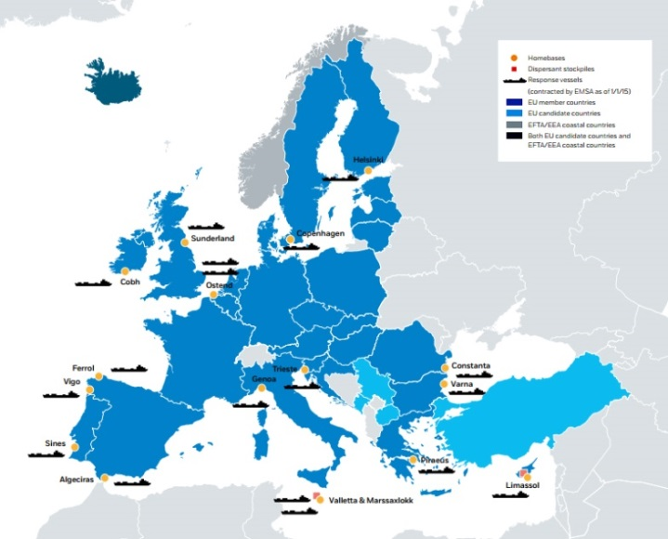
Source: (GREEN4SEA, 2015)

Table 3. European regional agreements with regard to oil pollution.
Region | Agreement | Year signed | Countries participant
The North Sea | Bonn Agreement | 1969 | Belgium, Denmark, France, Germany, Ireland, The Netherlands, Norway, Sweden, and the United Kingdom
The Baltic Sea | Helsinki Convention (HELCOM) | Originally signed in 1974 (new adoption in 1992) | Denmark, Estonia, Finland, Germany, Latvia, Lithuania, Poland, Russia and Sweden
The Mediterranean area | Barcelona Convention | Originally signed in 1975 (new adoption in 1995) | Albania, Algeria, Bosnia and Herzegovina, Croatia, Cyprus, Egypt, the European Community, France, Greece, Israel, Italy, Lebanon, Libya, Malta, Monaco, Montenegro, Morocco, Slovenia, Spain, Syria, Tunisia and Turkey
The North East Atlantic | Lisbon Agreement | 1990 | Portugal, Spain, France, Morocco
The Black Sea | Bucharest Convention | 1992 | Romania, Bulgaria
The extended North-East Atlantic | OSPAR Convention | 1992 | Belgium, Denmark, Finland, France, Germany, Iceland, Ireland, Luxembourg, The Netherlands, Norway, Portugal, Spain, Sweden, Switzerland and the United Kingdom
Source: own compilation (non-exhaustive sources) based on (EMSA, 2016)
As shown in table 3, countries ratified several conventions. Figure 3 gives an overview of the countries that are part of several agreements and EMSA is pointed out.
Figure 3. International frameworks for managing marine pollution.
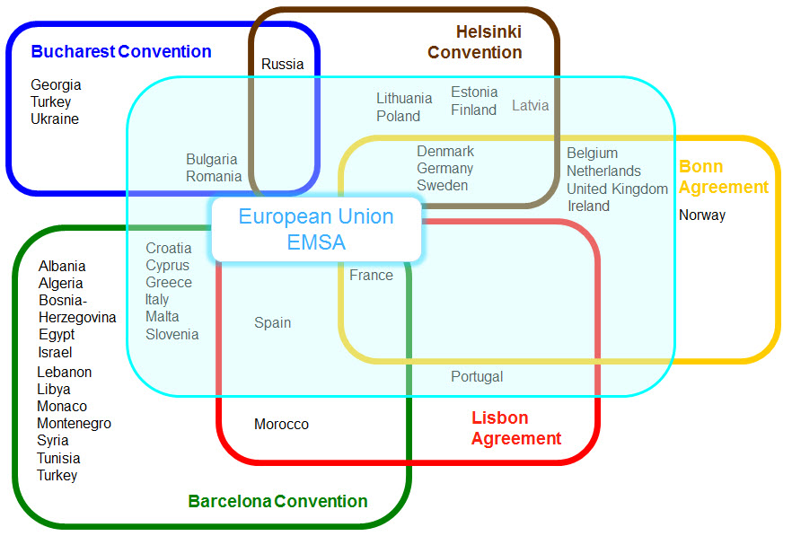
Source: (EMSA, n.d.)
Belgium and The Netherlands ratified the Bonn agreement. This agreement is the oldest agreement by which the North Sea states work together to help each other in combating pollution. The mutual aid refers to maritime disasters and chronic pollution from ships and offshore installations; and to carry out surveillance as an aid to detecting and combating pollution at sea (“Bonn Agreement | Working Together For Cleaner Seas,” n.d.). The area covered by the Bonn agreement is presented in figure 4. Finally, the OSPAR convention (Convention for the Protection of the Marine Environment of the North-East Atlantic) is the mechanism by which 15 Governments & the EU cooperate to protect the marine environment of the North-East Atlantic.
Figure 4. Area covered by the Bonn agreement.
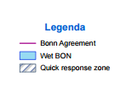
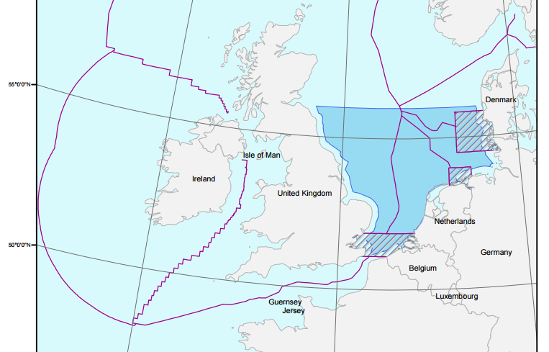
Source: (“Noordzeeloket | Government of The Netherlands | Maritime zones in the North Sea,” n.d.)
As seen in figure 4, the area covered by the Bonn agreement overlaps with the North See. Noticeable is that within this area, there are three quick response zones. One of these zones covers the coastal area of Belgium and the Netherlands, in the vicinity of the ports of Antwerp and Rotterdam respectively. In a Quick Response Zone, immediate actions must take place in maritime accidents and each Party has the right to start response actions immediately regardless in whose National Response Zone the pollution has occurred(“Bonn Agreement | Working Together For Cleaner Seas,” n.d.).
Nonetheless, the public authorities from the Greater North Sea also collaborate under the BE-AWARE project. This project has quantitatively identifies the risk and magnitude of mineral oils spills in the Bonn Agreement areas and undertakes a qualitative risk assessment for hazardous and noxious substances.
Contrary to collaboration agreements signed at regional level, the relationship at operative level between similar organizations of different countries is limited. For example, the exchange of good practices between port authorities or contracting companies having their activity in ports of the North Sea is minimal. The main reasons for this situation are linked to competition. Equally, the relative distance between intervention teams is too high to share oil spills cleaning equipment, in case of small spills. For this type of events, the procedures and intervention plans are rather developed locally and based on own experience. Nevertheless, local authorities, communities and business organizations evaluate the response notification and response plans as being sufficient.
The following section gives a detailed overview of the oil spill response organization structure in and around the North-West European ports.

Oil spill response in ports (collection of cases studies)
This section discusses in-depth the organizational structure of oil spill response in and around ports. The organization structure for oil spill response in the ports of Antwerp and Rotterdam is presented from two levels. Firstly, an overview of the response national and regional authorities is given. Secondly, the problem of oil spills is presented from a local, port perspective.

Oil spill response of Belgian authorities in/around the port of Antwerp
This section gives an overview of the response of Belgian authorities with regard to oil spills. Firstly, details regarding national organizational matters are addressed. Emergency response plans, responsible authorities and intervention action are presented from a federal perspective. Regarding emergency interventions, a distinction between ‘sea’ and ‘land’ needs to be made. Secondly, looking from the organization scheme, the involved parties, the equipment used and the way the financial matters are handled are discussed in-depth. This overview is put forward from the perspective of authorities responsible for oil spills reported at the port of Antwerp.
    - National organizational framework (the case of emergency interventions)
The organization structure of public authorities in Belgium follows a pyramidal scheme. The first level is represented by municipalities. The municipal authorities take responsibility of events that happen at local level. The second layer of responsibility is represented by provincial authorities which covers predefined geographical regions. Thirdly, the federal level takes the organizational responsibility of the entire country.
The Counter-Pollution Manual describes the national organization structure of Belgium in case of pollution at sea. For oil spills that affect several regions, the intervention teams must follow the general emergency intervention plan. The territorial sea and the exclusive economic zone of Belgium are presented in figure 5. Moreover, the Bonn agreement coverage is also illustrated.
As seen in figure 5, the area of Belgian authorities’ responsibility overlaps completely with the zone empowered by the Bonn agreement. Moreover, it is also one of the quick response zones stipulated in the Bonn agreement, therefore in the eventuality of an urgent pollution threat, it gives authority to each of the parties to intervene.
Belgian authorities have not developed a specific intervention plan specially dedicated to oil spills intervention. In case of a catastrophic event, the national contingency plan for the North Sea ("General Emergency and Intervention (GEI) Plan North Sea") is activated. The GEI Plan North Sea describes the organisation of an overall, multidisciplinary response structure to the various emergency situations and incidents that may happen at sea and which require a coordination or management from Belgian authorities, such as: maritime emergencies, Save And Rescue (SAR) and medical evacuations, marine pollution (oil or other harmful substances), incidents in windmill farms, etc. The Governor of West‐Flanders acts as the coordinator of the GEI Plan North Sea.
Figure 5. Belgian exclusive economic zone and territorial sea.
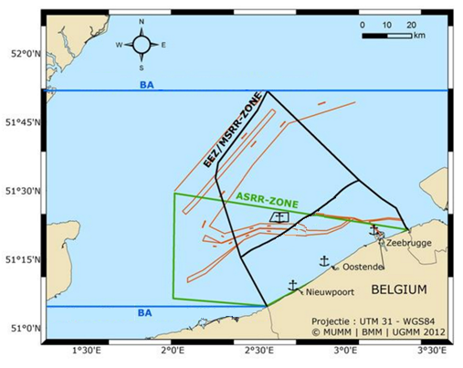
Source: (“Werkingsgebied | Kustwacht,” n.d.)
Figure 6 presents the authorities responsible and the responsible coordinator in case an emergency situation occurs. An oil spill is handled as a situation that requires immediate intervention. Depending on its severity, each incident report is individually handled and evaluated by the Belgian responsible authorities as presented in figure 6. The impact of an event could be local, provincial or federal. As consequence, it is from this perspective that the authorities need to coordinate the intervention actions. Hence, for each incident, an intervention plan has been developed and has to be followed. Each intervention plan, regardless its severity, follows the organisational directives given by KB/16/02/2006. In case of minor pollution, the local authorities are responsible for coordinating the protection and the cleaning up process. A distinction is made between oil spills that happen at sea or on land. For land interventions, the municipal authorities take the coordination responsibility, while for the sea, the port authorities have to coordinate the intervention actions. In case of major pollution threatening or affecting multiple municipalities, the Civil Protection intervenes for deploying the equipment for the protection and clean‐up. This is done as well under the coordination of the Governor or the Minister of Internal Affairs.
Figure 6. General emergency response scheme and responsible coordination.
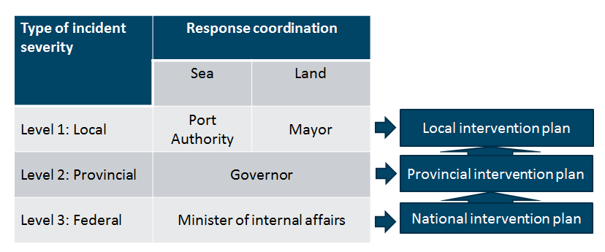
Source: own composition based on KB/16/02/2006
      - Disciplines involved in emergency response actions
This framework gives the coordinating authority the possibility of activating one of the five intervention disciplines. These five intervention disciplines are presented in figure 7.
Figure 7. Intervention disciplines to be activated in case of emergency situations.
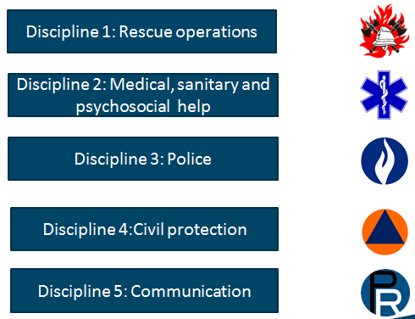
Source: own composition based on KB/16/02/2006
The first intervention discipline covers tasks and duties for rescue operations. It involves the support of fire brigade. The second discipline foresees actions with regard to medical, sanitary or psychosocial help. The third discipline covers the police intervention with regard to public order. Discipline four comprises the organization of logistics support from the civil protection department. The fifth discipline deals with the communication of information and directives to the population and to the media in an emergency situation. This task is fulfilled by the Governor’s communication services.
The following section gives a synopsis of the emergency response organization for events that occur at sea.
      - Emergency intervention at sea
Every event that occurs in the Belgian territorial waters and that requires emergency intervention is treated at the provincial level. At this level, the competent national authority that has the overall responsibility for oil pollution response is the Directorate-General Environment of the Federal Public Service Health, Food Chain Safety and Environment.
Figure 8 presents the location and the coastal vessels that are prepared to respond in case of oil pollution at sea. These vessels are owned and operated by the aforementioned Ministry.
Figure 8. Vessels prepare to respond to oil spill at sea.
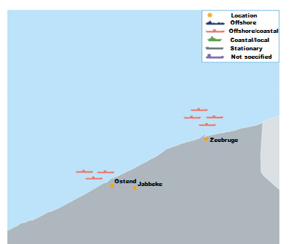
Source: (EMSA, 2016)
According to EMSA (2016), the Belgian Navy permanently maintains one of three vessels on stand-by at Zeebrugge to accomplish different tasks, including SAR, fisheries inspections and anti-pollution operations. The three vessels available for such duties are: A950 VALCKE, A963 STERN and A996 ALBATROS. The vessels do not have permanently anti-pollution equipment and booms on-board. Skimmers or dispersant spraying equipment would be loaded as needed.
      - Emergency interventions on land (the area around port of Antwerp)
The intervention structure to emergency situations that happen on land is similar to the one presented in section 2.1. For events that have a federal impact, the Belgian authorities rely on the equipment owned by the Ministry of Internal affairs and used by the Civil Protection services. On land, intervention equipment is located in the civil protection scenes in Brasschaat, province of Antwerp and Jabbeke, province of West-Flanders. The authorities responsible in case of an oil spill is reported in and around the port of Antwerp are: the Antwerp Port Authority (APA), the Flemish Department of Maritime Service Provision and Coast (Agentschap Maritieme Dienstverlening en Kust- MDK), the Mayor of Antwerp, the Governor and the Minister of Internal Affairs. According to the severity of an event that requires emergency intervention, the area of responsibility for each of the aforementioned mentioned authorities is presented in figure 9.
Figure 9. Areas of responsibility in case of oil spill in and around port of Antwerp.
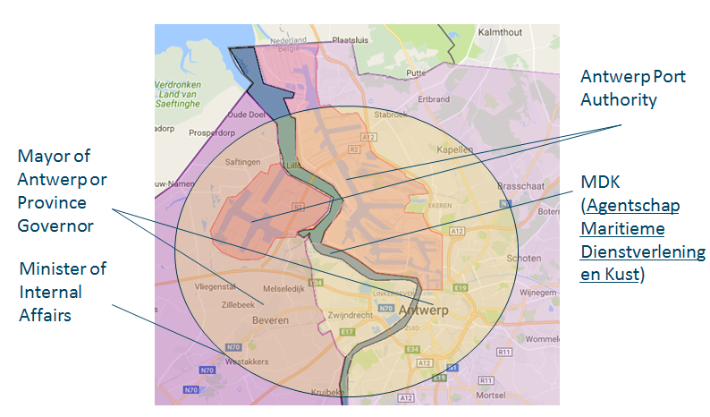
Source: own composition based on interviews
As seen in figure 9, the port of Antwerp is neighbouring two Belgian provinces, the province of Antwerp and the province of Eastern-Flanders. The responsible authority for each of the two areas is the Province Governor. Moreover, the port of Antwerp is developed on the both sides of the river Scheldt. The responsible authority for the water quality and pollution on the river Scheldt is held by the province governor in collaboration with MDK (Agency for maritime and coastal services). The latter regional government agency ensures safe and smooth shipping to and from the Flemish ports. Similarly, several municipalities are located around the port area for which the Mayor takes full responsibility. In the eventuality that an oil spill threatens areas of both Provinces, the Minister of Internal Affairs takes responsibility for oil spill defence actions.
    - Oil spill response in the port of Antwerp
The Antwerp Port Authority (APA) has the responsibility of managing the waste and pollution issues in the port of Antwerp. APA is responsible for cleaning the oil spill on the water as shown in figure 9. This area contains the navigable waterways (inside the port), the quays, the ships' sides, the river banks and the civil engineering structures. To this matter, APA has developed its own oil spills intervention plan. This plan is in accordance with provincial and federal regulation of Belgium.
The port instructions stipulate that the oil spills should be reported to the harbour master using the VHF channel 63 or at the responsible dock master for calamities using mobile or fixed phone. The responsible dock master for calamities has the role of further communicating the report to the port authority and of conducting a first evaluation of the incident. After this decision, a calamity unit is formed and is empowered to take decisions with regard to mitigation and cleaning actions. The calamity unit is directly managed by the calamity manager of the Harbour Master’s Office. The other parties involved in oil spill interventions are presented in table 4. Internal procedure specifies the contact details of (oil) spillage watcher during office and non-office hours.
Since January 2015, the APA has contracted Brabo Cleaning Company ( BCC) to respond and act in cleaning operations with regard to oil spills. The elements which, in case of an incident, fall under the cleaning responsibility of BCC are: the navigable waterways, the quays, the ships' sides, the river banks and the civil engineering structures. Opting for a fixed yearly contract, the APA aimed at increasing the quality of the oil spills cleaning service. Here is to be mentioned the response time, the preparedness level and availability. Hence, the contractor holds the monopoly of oil spill cleaning operations in the port of Antwerp, but in exchange it has to meet specific conditions. Table 4 presents the authorities participating in case of oil spill that requires intervention.
Table 4. Stakeholders involved in the oil spill response procedures at the port of Antwerp.
Stakeholders participating in oil spill response
Antwerp Port Authority
Harbour master
Service provider - Brabo Cleaning Company (BCC)
Water police
Offender
Source: own composition based on interviews
In case an oil spill occurs, the APA, through the harbour master and/or the dock master, has the authority to supervise and organize the response actions. The dock master is appointed as commander in charge for the cleaning operation and leads the oil spill response action. If needed, the waterway police can join the local intervention team. In this case, the role of the waterway police is to determine a safety perimeter, to participate in common actions that lead to good handling of the oil spill and to facilitate the cleaning procedures. Equally, the waterway police representatives complete a report in which all the details of the incident are mentioned. In case the presence of representatives from the waterway police is not needed, the report is made by the dock master in charge. Later, this report will serve as official proof of the incident characteristics. This report contains information with regard to location, type of oil spill, size (in sqm with approximation) and the possible responsible for the oil spill. Copies of the report are handed over to each of the involved parties. The BCC has to offer oil spill cleaning services as the contractual agreements with the APA.
      - Notification/oil spill response structure
The operational intervention scheme in case of oil spill response is presented in figure 9. The information flow and the cleaning responsibility is addressed from the perspective of the port authority.

Figure 10. Oil spill response flow-chart in the port of Antwerp.
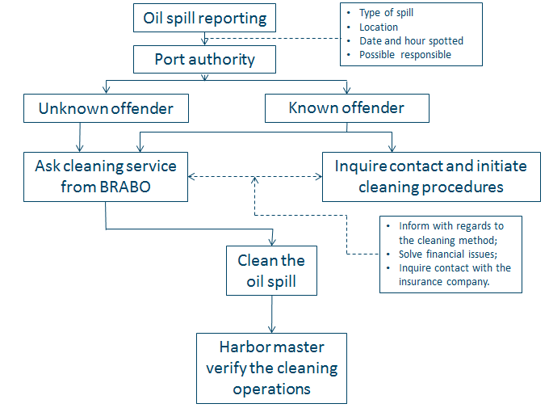
Source: own composition based on interviews
As presented in figure 10, all the oil spills that happen in the port of Antwerp have to be reported to the port authority. Every report needs to specify at least the following information: the type of spill, the location, the date and hour spotted and the possible responsible (offender). In case of an unknown offender, the port authority holds the cleaning responsibility and contacts the cleaning contracted company which cleans the spill. If the offender is known and he takes responsibility for an oil spill, the port authority arranges the cleaning operations for him. BCC is the only agreed oil spill cleaning company in the port of Antwerp, and no other cleaning means are allowed. In this case, the Antwerp port authority contacts the contracted cleaning company and informs the responsible person of the offending company. At this stage, the representative of the cleaning company takes contact with the offender and informs him over the cleaning method. At the same time, a first contact with the insurance company of the offender is made in order to clear the financial responsibility for the cleaning activity. At the end of each cleaning operation, the harbour master office has the responsibility to verify the cleaning intervention and give its final approval. The APA charges administration costs for cleaning operations only in case the polluter doesn’t take responsibility for its offence. After the proof of legal responsibility, an administrative fee, reflecting the lower level of administration, is applied as well to the cleaning operation costs.
For an effective oil spill response, APA through the harbour master office has developed a typology of three groups of oil spill for which different handling is required. Table 5 presents the categories of oil spills as classified by the APA based on their characteristics.

Table 5. Categories of oil spill present at the port of Antwerp.
Pollutant group | Type of spill | Observation
Group 1 | Gasoline | Fast evaporation.  Highly flammable.
 | Kerosene
 | Naphtha
Group 2 | Diesel | Evaporates completely in 24h under warm conditions.  Explosion risk.
 | Marine Diesel oil
 | Marine Gas oil
Group 3 | Medium Fuel Oil | Stays till 2 weeks in the environment.
 | Intermediate Fuel oil
 | Heating diesel (Mazout)
Other | Engine oil | Persists from 1 to 2 years in the environment.
 | Grease oil
 | Hydraulic oil
Source: own compilation based on interviews.
The following subsection will present the financial scheme and invoice flows in case of oil spills.
      - Financial responsibility and cleaning costs recovery flow chart
The APA values the principle of “the polluter pays” in case of oil spills. The financial flow of the financial matters with regard to the cost of oil spill intervention is presented in figure 11.
Figure 11. Financial flow of oil spill cleaning intervention at the port of Antwerp.
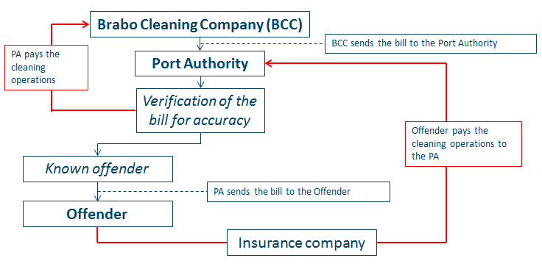
Source: own composition based on interviews
BCC is the only agreed oil cleaning company in the port of Antwerp. As shown in figure 11, after each intervention, they send intervention cost to the port authority. The port authority checks the invoice for accuracy and pays it to the cleaning company. In case of a known offender, the port authority inputs the cost to the offending company. The offender has the possibility then to pay the cleaning intervention cost into the account of the port authority. The intermediary bill check done by the port authority ensures that the same cleaning tariffs are used for every port stakeholder and no price discriminations are made (fair tariffs).
      - Prevention actions
In this section, the prevention actions taken by the responsible authorities in case of oil spills in the port of Antwerp are discussed. Although oil spills prevention actions are taken by the port authority and harbour master, oil spills still happen. The main sources of oil pollution in the port of Antwerp come from bunkering activity, either land side (negligence of third parties; spills that appear during excessive raining) or water side (historical sediments of oil which came to the surface during dredging activity).
The oil spill prevention actions are mainly coordinated by the APA and are set into practice through the activity of the harbour, dock masters and the waterway police. The first action on the prevention agenda against oil spill is to increase the awareness over the negative effects of oil spill pollution. Through actions conducted by the harbour master office, the port users are kept informed about the effects produced by oil spill to the environment, the effects on water traffic on cleaning operations, but also the extra cost incurred by the responsible parties. With regard to this matter, the harbour master recently conducted an awareness campaign to the port users, terminal operators and their clients over the possible effects of an oil spill in the Deurganckdok and the vicinity of the new lock (Deurganckdoksluis). As an effect, there is a positive feedback and the community collaborates to avoid oil spills. Another set of actions with regard to oil spill prevention are the controls conducted by the harbour master office together with representatives of waterway police. These controls are conducted at terminal sites and on board ships. In this regard, the waterway police has the authority to verify the authorizations and technical inspections terms of equipment present on terminal operator sites or on board of ships navigating in the port of Antwerp. Random and periodical controls are done on board ships (MARPOL control; engine log books are subject to controls). Unfortunately, these authorities do not have the expertise to control the technical equipment, so the control is limited only to documents checks. Another point on the prevention agenda of authorities in the port of Antwerp is applying fines to the port users which do not respect the regulation and the requirements for oil spill prevention. This method is used as a last tool to increase the responsibility of port users on oil spill pollution.
      - Media communication
Port authority takes the full responsibility for oil spills that are reported in the area of port of Antwerp. Media communication depending on the severity of each event is an important element in the oil response procedure. The APA has a public relation department which, in case of major oil spills, is activated. Usually, no special communications are released for oil spills that are reported in the port of Antwerp and are locally handled. Of course, depending on the situation, for example, in the eventuality of high public interest or oil spills that that have a considerable economic impact, a special media communication is released. The APA was not confronted with such a situation in the last 5 years.
      - Level of preparedness (equipment)
As presented in previous sections, the APA has the responsibility for managing the oil spill response in the port of Antwerp. In this regard, the APA takes the responsibility when it comes to oil spill incidents that occur in the navigable waters and quays of the port of Antwerp. According to own its decision, the APA has contracted BCC as the only oil cleaning company in the port of Antwerp. This section presents the level of preparedness to respond to an oil spill in the area of the port of Antwerp from two perspectives. Firstly, it gives an overview of the equipment available for intervention in case oil spills are reported in the port of Antwerp. This is done from the perspective of the private oil cleaning contracting company. Secondly, the level of preparedness of public authorities available to intervene is presented.
        - Level of preparedness of private contractor
The contract has been attributed to BCC as a result as a public bid, based on fix contractual requirements. The equipment currently owned by the BCC and used to combat oil spills in the port of Antwerp is as follows:
  - 2250 m oil screens (2000 m on board of vessels and 250m on a special trailer);
  - approximately 30 motor boats;
  - 4 drum skimmers;
  - 4 sweep arms;
  - A truck with crane and leak proof container;
  - 1.500 m² oil absorption pads;
  - 1000 m oil absorption booms;
  - 20 units oil absorbing sweep;
  - Ecological dispersion products.
Moreover, the contractual agreement foresees a fixed response time to interventions. Depending on the location of an oil spill the following time intervals must be followed. The first intervention team has to be on the spot after 30 minutes after the call. After 40 minutes, the second vessel carrying the floating booms has to be as well on at the intervention scene and start laying down protective booms. These intervention time slots are kept due to strategical located intervention boats. There are three intervention boats for oil spill intervention in the port of Antwerp. Figure 12 shows the location of the intervention boats. The intervention boats in the port of Antwerp are: the Flandria 9, the Pollution-Fighter and the Neptune with a containment capacity of 40, 30 and 20 m³ respectively.

Figure 12. Location of oil spill intervention vessels in the port of Antwerp.
Source: own composition based on interviews
The intervention boats owned by BCC are located in the docks 401, 614 and 1105 of the port of Antwerp. At these premises, there is always of team of four to five boatmen that can intervene 24/7 to any oil spill call.
The BCC has no fixed contractual arrangement with regard to waste oil disposal. In the area of port of Antwerp, there are several oil waste collecting companies. After each intervention, the vessel tanks are discharged and the oil is transported to a specialized oil disposal company. Companies such as MTD or MAC² offer waste oil discharge facilities/services.
        - Level of preparedness of public authorities
The help of civil protection is required on major interventions where the port authority and the capacities of the service provider are overwhelmed (BCC cannot intervene). The decision to mobilize the emergency service is made by the local responsible authorities such as: the port authority, the mayor or the province governor. The role is to offer help and extra equipment to stop the spread of the spill. If necessary, extra help can be offered as well on oil collection. This intervention support is given at request based on the availability of equipment and personnel. The oil intervention plan followed by the Civil protection intervention team is similar to the general intervention plan. The equipment which is used in oil spill interventions is specific for oil collection. Special containers, pumps and barriers are disposed in case of interventions on oil spills.
The intervention of civil protection is done in close collaboration with other intervention teams. This model was selected based on the legal responsibilities and the past oil spill response experience. Usually the tactical response is decided on spot and the team is coordinated by an intervention officer. The harbour master points out to him which areas need intervention. There is a good organization and structure. Members of the intervention team know what they have to do.
The intervention procedure stipulates that the civil protection team must leave from their base in between 10 to 12 minutes after the request is made. The arrival at the location depends on each incident and is not regulated. In any case it should be kept in normal limits and as fast as possible.
The intervention of civil protection has the following structure. The call is made. The officer in charge mobilizes his team. He informs the sub-officer about the location, the incident and materials needed to intervene. The main officer leaves to the location at the incident. Meanwhile the sub-officers take the intervention equipment and leave to the location. The main officer, once having arrived at the location of an event, takes contact with the persons coordinating the intervention and informs his team about the operational matters. Antwerp municipality has since 2005 an emergency intervention coordination centre located in the vicinity of the port at the fire brigade in Northern Antwerp (Noorderlaan 69, 2030 Antwerpen, Belgium). This coordination centre is responsible for strategic decisions. Equally, the fire brigade owns a truck equipped as a mobile coordination centre with a meeting room and communication equipment. This truck is set on the location of the emergency intervention for operative decisions management.
In the eventuality of oil spill collection, the Civil Protection disposes of several oil spill skimmers and a 9000 m³ tank to collect the residual waste. The oil waste is usually disposed to MAC², (http://mac-2.be/) a specialized company in waste recycling and cleaning. There is not a fixed contract and the oil waste is brought when necessary (usually after each intervention). An invoice is issued for every visit. The cost of the intervention is re-covered ex-post by the governmental agency.
      - Level of preparedness (training / evaluation procedures)
Each person involved in the direct intervention on oil spills has to have a special training. In regard to this issue, table 6 presents an overview of the training that each organization provides to its personnel involved in the oil spill response in the Port of Antwerp has.
Table 6. Overview of training followed by intervention personnel.
Organization | Personnel | Frequency | Type of training
Antwerp Port Authority | Dock master | 2 times per year training event | Communication training
Brabo cleaning company | Team coordinator  Boatmen | 1 time course;  Internal training. | IMO level 2 course
Civil protection | Intervention personnel | 200 hours of training per year (depending on time availability) | Equipment usage and communication training
Source: own compilation based on interviews
Further training is provided to personnel in case of relatively long period of inactivity. By internal regulation, each member of the civil protection has to have an overall amount of 200 hours of training per year. Equally, BCC is currently working in developing an overview of the hours and training requirements for each boatman. This overview will be used to evenly distribute the working and training hours over the employees. The scheduled exercises cover topics such as: response to notification, communication to parties, use of equipment or on-water simulations. After each exercise, a debrief is held and contact details of the involved parties are updated, if necessary.

Oil spill response of Dutch authorities in/around the port of Rotterdam
This section gives an overview of the response of Dutch authorities with regard to oil spills. Firstly, details with regard to national organizational matters are addressed. Emergency response plans, responsible authorities and intervention action are presented from a national perspective. With regard to the interventions, a distinction between ‘sea’ and ‘land’ needs to be made. Secondly, looking from the organization scheme, the involved parties, the equipment used and the way the financial matters are handled are discussed in-depth. This overview is put forward from the perspective of authorities responsible for oil spills reported in the port of Rotterdam.
    - National organizational framework (the case of emergency interventions)
In The Netherlands, the Ministry of Infrastructure and the Environment is responsible for the main infrastructure facilities. This includes the main road network, the main waterway network and water systems. Rijkswaterstaat (RWS) is the part of the Ministry with executive responsibility for water quality management in The Netherlands. Furthermore, RWS has delegated to local authorities, such as municipalities, provinces or port authorities the pollution cleaning responsibility. In case of oil spills reports, these organizations ensure a fast response procedure. ( http://www.rijkswaterstaat.nl)
In and around the port of Rotterdam, the main shipping routes are as well under the governance of public authorities, viz. RWS. The latter has delegated the Rotterdam Port Authority (RPA) to manage the water pollution and water cleaning actions. This means that when the RPA is dealing with a water incident, the Minister still has the authority to control their actions and decisions. Equally, if the RPA signs a contract with a private company with regard to water cleaning operations, the Minister has the authority to look over it and agree or amend it.
Figure 13 puts forward the Dutch exclusive economic area and the territorial sea. This area completely overlaps with the intervention area stipulated in the Bonn agreement.
The response plan to land emergency situations in The Netherlands is centred on the incident management actions of the so-called safety region. In 2010, according to the new law regarding the safety regions, the responsibilities with regard to crises and disasters response were transferred from the local level to the regional level of the government. A safety region is a cooperation of the public management of villages and towns regarding crisis and disaster management within this region. The main goal of establishing this law was to increase the level of quality and preparation of the public services in relation to crises and disasters. There are currently 25 safety regions in The Netherlands. The port of Rotterdam area is contained in the Rotterdam-Rijnmond safety region. The safety regions provide a 24/7 service and is coordinated by an officer in charge. Apart from port related incidents, the safety region also responds to other incidents such as road accidents, rail calamities etc.

Figure 13. Dutch exclusive economic area and territorial sea.
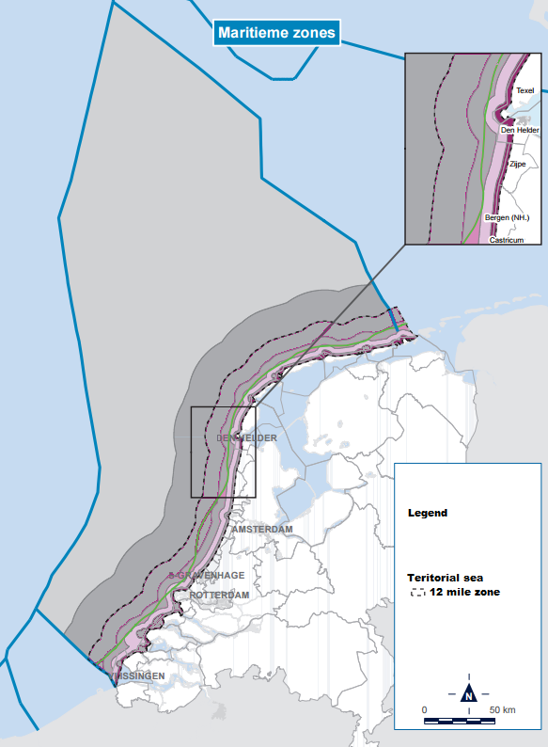
Source: (“Noordzeeloket | Government of The Netherlands | Maritime zones in the North Sea,” n.d.)
Each safety region closely collaborates with local authorities and coordinates the local intervention operations. In case of incident they have to pay attention that the message they receive is very clear and according to the severity of the incident. If they take a wrong decision, for example the supra estimate the severity of an oil spill, the polluter has the legal means to prosecute the decision. As well, if there are not enough cleaning means, or poor intervention, the officer in charge is also responsible for his poor service.
      - Emergency intervention at sea
In the eventuality of pollution incidents at sea, The Netherlands disposes of own means of intervention and cleaning equipment. Figure 14 presents the location and the coastal vessels that are prepared to respond in case of oil pollution at sea.
Figure 14. Vessels prepare to respond to oil spill at sea.
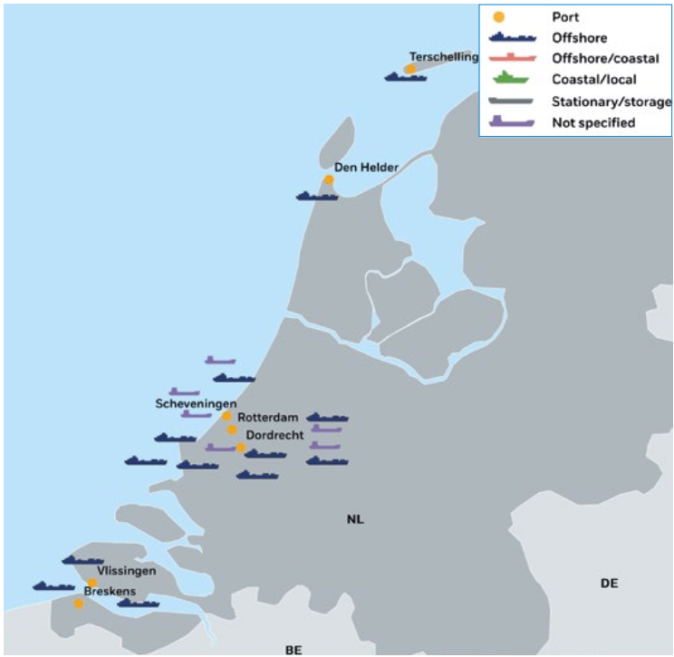
Source: (EMSA, 2016)
According to EMSA (2016), The Netherlands permanently maintains 19 vessels on stand-by at the coast for anti-pollution related interventions. Five of the vessels are owned by the government and form what is referred to as the first line of defence. They were designed specifically for oil spill response. Vessels forming the second line of defence are mainly hopper dredger vessels that have been slightly modified to accommodate oil recovery equipment. All contracted vessels are trained and exercised twice per year.
      - Emergency interventions on land (Example the port of Rotterdam)
In case of incidents that happen in the inland navigation water ways, RWS takes the responsibility for coordinating the response actions. For inland navigation waters, RWS has contracted a private company to intervene for cleaning actions. For the navigable waters in the port of Rotterdam, this responsibility was delegated to RPA.
The intervention coordinated by RWS, on inland navigation waterways, is based on the following steps. These steps are needed to be taken in the first hour, also known as “the golden hour”. The officer in charge needs to assess the situation, address the polluter and hold him liable for the incident. This is done firstly by phone and then it is mentioned on an official hard copy notice. As well, the polluter receives the option of bringing his own cleaning means (a contracting party) together with his own cleaning plan. This cleaning plan has to be approved by the officer in charge. In case the cleaning plan is not agreed by the officer in charge, the polluter gets another chance to modify it. If the cleaning plan is not agreed, the officer in charge has the authority to ask the cleaning services of the general cleaning company. In most cases, the polluter does not ask for the cleaning services of another cleaning company.
During the period of any intervention, coordinated by RWS, the main stakeholders and the affected municipalities are kept informed with regards to the details of the incident. This is done via the dispatching centre of the safety region. Equally, the officer in charge instructs the waterway traffic dispatcher with regard to the actions he needs to take. Cooperation with the municipality and the provinces is very important in the on-land incidents.
Depending on the characteristics of each incident, media communications are also released. The frequency of these releases depends on the type incident, the companies involved and the public interest. As well, if there is wildlife involved, then the media interest is very high.
In case a spill is reported in the port of Rotterdam, the PRA coordinates the response actions through the harbour master’s office. An officer in charge takes full responsibility for the intervention coordination. The area of responsibility is presented in figure 15.
Figure 15. Area of responsibility in case of oil spills occurring in and around the port of Rotterdam.
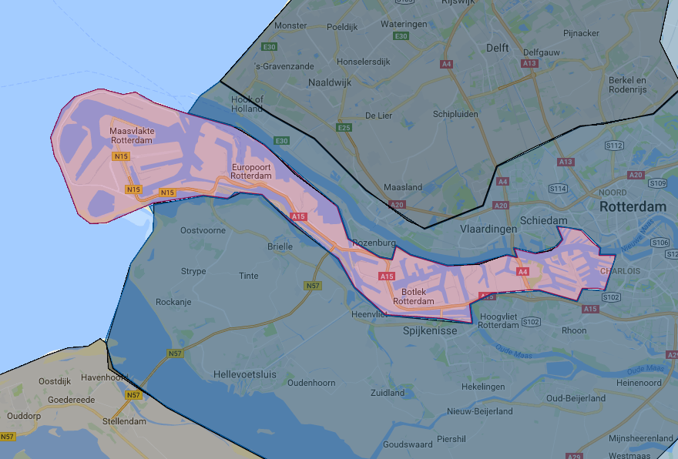
On water outside the port area: Rijkswaterstaat (RWS)

On water inside the port area:
Rotterdam Port Authority
On land:
Safety regions
-Haaglanden;
-Rotterdam-Rijnmond

Source: own compilation based on interviews
As seen in figure 15, the area of responsibility in case of emergency situation of the RPA is neighbouring with the province South Holland. The Minister of infrastructure and the environment is the supervisor of the water quality and has delegated pollution cleaning tasks to port authorities (for the port basin) and the province governor (for the inland navigation waterways around the port). In particular, inside the port basin, RPA take responsibility for coordinating the intervention actions as for waters outside the port basin, RWS does it. By coincidence, they have the same contractor for cleaning, namely the HEBO.
The main causes of oil spills in the waters surrounding the port of Rotterdam are: the negligence on board, human error, equipment fail, bunkering operation or collisions.
The notification procedure for oil spills that happen in the vicinity of the port of Rotterdam, stipulates that RWS, safety region and/or, by case, RPA should be informed. For accidental spill, the vessel captains dispose from a fixed VHF frequency for incident notifications. If there is an oil discharge with an unknown source, the reports can be made either to the police, the municipality, to the emergency number or directly to RWS. This type of notifications is most of the time done by phone. The first person must collect as much as possible information. Information with regards to location, size and circumstances are necessary.
If there is a notification of an oil spill with an unknown source, the officer on duty (representative of either RWS, safety region or RPA) gets the message and has the task to check whether the message is reliable. This is done by sending an investigation team on the spot and checks. In the same time, the cleaning company is contacted and set in stand-by in case of further intervention is needed.
The officer on duty disposes of a database with substances that could be disposed in water. He has the task to check the characteristics of the spill and its in - water behaviour. In case the substance evaporates fast, then the officer takes no further actions. For substances like heavy fuels or crude oil, the officer in charge proceeds to further cleaning actions.
The officers on duty are trained persons that have knowledge over the following topics: the general ship behaviour, the characteristics of intervention equipment, the pollution types, the type of information he need to take into account on oil pollutions, the weather conditions at sea, the behaviour of oil spill and the day/night operations.
In the eventuality of an oil spill intervention, the officer in charge is always present on the spot of an oil spill. As well, also if the polluter organizes its own cleaning intervention, a civil servant has to be always on board of the ship or at the scene of the incident. At the end of the intervention, he gives his consensus with regard to the cleaning operations. The oil spill cleaning interventions conducted under the command of RWS use both the equipment of HEBO and also own equipment. The oil spilled in water is disposed at specialised oil spills companies. In some cases, if the spill was vegetable oil, the polluter claims it back. This situation happens very seldom. For oil which had hit the shore the waste (mixture of oil and sand) is transported to a disposal plant in Moerdijk where the mix is incinerated. After the incineration procedure, the resulting material is used in construction work such as road infrastructure.
    - Oil spill response in the port of Rotterdam
This section discusses the organizational details of the Rotterdam port authority in case an oil spill is reported and details the prevention actions, the preparedness level of the intervention teams, the equipment used and the trainings that the intervention personnel follows.
The port authority has its own interest that the port is functional and can be operated 24/7. For this reason, the port of RPA was mandated to organize its own oil spill response procedure. The RPA has interests in not disturbing the vessel traffic and the turnaround times for vessels coming in the port.
Table 7 presents the organizations which are involved in oil spill response in the port of Rotterdam.
Table 7. Organizations involved in oil spill response in the port of Rotterdam.
Organizations involved in oil spill response | Role
Rijkswaterstaat (RWS) | Supervises the decisional activity
Rotterdam port Authority | Supervises the oil spill intervention
Harbour master | Incident commander (the officer in charge)
HEBO | Oil spill cleaning company
Fire brigade | Intervene if a spill contains substances from dangerous goods category
Polluter | Complies with decisions taken by the in charge commander
Third parties
Source: own compilation based on interviews
The RPA does not own cleaning material or personnel trained to respond to oil spill interventions. The contract with the cleaning has been made for 5 years; and in 2017, it needs to be renewed. The contracting cleaning company in the port of Rotterdam is HEBO. This company has a non-stop stand-by contract (24/7) for the oil spill intervention. The oil spill response time stipulated in the contract is one hour. To keep this short time interval, the company disposes of several intervention boats located in different areas in the port. As well, HEBO manages its own boats, personnel and locations. The contractual agreement also states that the contractor must be able to dispose his vessels at two locations in parallel. As consequence more intervention boats need to be available. The collection capacity of the intervention vessels is 350 m³/5 hours of liquid waste.
Besides the permanent service of HEBO, the port of Rotterdam benefits from the activity of Schermenpool (SRH). This association takes care of the logistics, the maintenance and administration of oil protective equipment present in the port of Rotterdam. It has the membership of 12 companies and 17 terminals that operate in the port of Rotterdam. SRM was established at the initiative of several companies located in the port of Rotterdam who observed that the containment oil booms could be deployed in a more effective manner. As a consequence, a substantial reduction in the number of in-use oil booms was realized.
The following sub-sections describe the prevention, notification and preparedness level of authorities responsible to intervene in oil spill response in the port of Rotterdam.
      - Notification/oil spill response structure
The RPA takes the responsibility of oil spill incidents to be sure that they can provide a response that will not affect the port’s image. In other words, the RPA manages the contract with the oil spill cleaning services keeping in mind the economic effects on third parties, delays on the polluter and the impact on vicinity inhabitants. The port authority wants to please everybody, including the polluter, and the oil spill cleaning is seen as an additional service provided by the port authority to the port users.
The notification procedure and the intervention decision on oil spill is detailed in figure 16. The Port Bye-laws state that all spills have to be reported to the RPA or the Harbour Master immediately. Failure to comply with this procedure is punishable by law. Details that are required to be reported are: the name of ship, the name of berth, the activity it was under progress and the incident.
Figure 16. Oil spill response procedure in the port of Rotterdam.
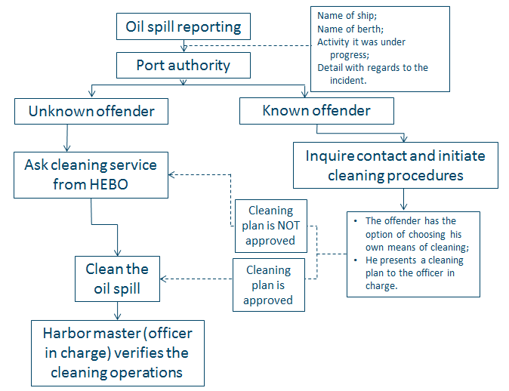
Source: own compilation based on interviews
The RPA has several patrol vessels which are 24/7 available to patrol the area of the port. If the patrol vessels spot a spill, they immediately report it to the harbour master. As seen in figure 16, if an oil spill is reported, the following intervention procedure is followed. The harbour master establishes a command centre that is responsible for the situation management and oil spill cleaning decisions. The officer in charge informs the cleaning contractor about the potential for an oil spill response, visits the location of the spill and decides whether it requires intervention. Further actions are directed from the command centre that is organized in the harbour master’s building. Here, if necessary, all the involved parties come together. The stakeholders possible involved in a spill are shown in table 7. Two scenarios are followed in case of oil spill in the port of Rotterdam.
- If the polluter is known, then the legal representative is notified to clean the spill. At this stage, the polluter has to choose the company it wants to use. He is responsible, by regulation, to clean up the mess. He is free to choose own cleaning means. If he chooses to use the cleaning services of another cleaning company or by his own means, then he has to make a plan of action. The plan of action has to be approved by the officer in charge. If the plan is not approved, he gets a second chance to revise it in about 15 minutes. If it is not accepted, the officer in charge takes the decision to contact HEBO and use their cleaning services. The cleaning costs are then sent to the polluter with an extra administration fee of 15%. The cleaning officer has to finally approve the quality and collection of the spill in the water. If the port authority takes the decision to contact HEBO, then they pay the bill and send it afterwards to the polluter with a fee. The port authority also pays HEBO for the stand-by.
- If the polluter is not known, the RPA contacts the cleaning contracting company, who initiates the cleaning operations. Similarly, the cleaning operations are supervised by the officer in charge. An investigation is then started to determine the pollution source and point the liable party.
Also within the incident management procedure, certain steps are mentioned with regard to third party communication. For example, when an oil spill is reported in a port’s basin, the officer in charge contacts all the third parties (directly and indirectly) affected by the spill and invites them to a meeting. This meeting has the scope to inform them over the existence of the oil spill and give details with regards to type of spill, cleaning procedures and the estimated duration of the cleaning procedure. The third parties do not take part to decision making as the cleaning procedure might have started already. In the eventually of disagreements with regard to the response procedure, the officer in charge takes responsibility for his decisions and commands the cleaning actions
After each intervention, the waste coming from oil spills is transported and disposed at special disposal companies located in the port. The disposal procedure is not conditioned by a predetermined fixed contract.
In the eventuality of an oil spill in the port of Rotterdam, the RPA holds the media connection via the communication department. As of major spills, the communication tasks are given to the representatives of the safety region.
There are oil spill notification and intervention procedures also for the companies located in the port of Rotterdam. These procedures are put forward by the safety responsible authorities for the port of Rotterdam area, namely the port authority and the safety region. These procedures describe step by step the actions that the legal representatives of companies need to pursue. These procedures contain updated telephone numbers of responsible authorities and port officer in charge.
The following section gives an overview of the cleaning equipment used for oil spill intervention in the port of Rotterdam.
      - Financial responsibility and cleaning costs recovery flow chart
In case of a reported oil spill, the port authority holds the polluter liable for all the direct and indirect effects of it. In this case, the polluter is responsible for covering a range of costs from cleaning operations to economic effects of delays that other vessels have registered. Figure 17 presents the financial cost flow of the cleaning operations.

Figure 17. Cleaning cost recovery flow in case of oil spill in the port of Rotterdam
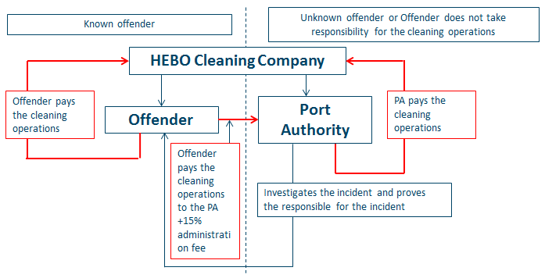
Source: own compilation
Figure 17 shows the cost recovery procedure followed in the port of Rotterdam. The cleaning company take direct contact with the offender to settle the financial issues of the cleaning operation. The RPA intermediates the cost of cleaning operations only if the polluter does not acknowledge his responsibility for the oil spill. In this case the cleaning cost bill is added also the administration cost for the port authority.
The port authorities as well as the other water quality managers in the Netherlands have the legislative means to detain the vessels until the cost of oil spills is covered. For example, if a ship has polluted the waters inside the port of Rotterdam and the captain or the ship owners’ society denies the responsibility for the pollution, it can continue its journey. However, the RPA may bring a law suit against the polluter and if the process is won, the RPA has the legal right to detain the vessel in any port. The detention can be prolonged until the full cost of the cleaning operations and process were paid.
After each intervention, an ex-post investigation is carried. During this evaluation, the operational decisions are evaluated from the perspective of their cost effectiveness. In some cases, the operational decisions are influenced by external factors such as threat to population or wildlife, the environmental impact and potential threat to the port’s image. In these cases, the cost effectiveness of intervention actions is less important.
      - Prevention actions
The main oil spills in the port of Rotterdam are due to bunkering activity, discharging of vessels, equipment failure (broken valves) or human error during operation/manipulation of installation. In this regard, the port authority takes actions to increase the awareness of the negative effects produced by oil spills. As well, in case of dredging activity, a preapproved plan with regard to oil sediments and the river basin has to be made. This type of plan prevents the accidental spills provoked by dredging activity and they make the dredger liable in case of miss-manipulation of the equipment. For example, during the construction period of a new jetty, the construction company has to secure the area with protective oil booms.
      - Media communication
The RPA holds a separate department for media communication. Every oil spill notification is individually evaluated by the port authority and decisions regarding the media communication are then taken. In the eventuality of a major oil spill a special press communication is released. Press communications are not released for all the oil spills that happen in the port of Rotterdam. However, all the oil spills which are reported in the port of Rotterdam, no matter whether they require intervention or not, are reported to RWS. Equally, in the eventuality that an oil spill is threatening a major community or the media shows higher interest for an oil spill, a special press communication is prepared and communicated.
      - Level of preparedness (equipment)
As discussed in section 4.2.2., the RPA has been mandated to manage the on water pollution cleaning actions in the area of the port. Depending on the type of spill, the fire brigade and the safety region takes over the responsibility of the cleaning operations. For example, this is applicable for gasoline spills, highly inflammable substances, and/or for spills coming from products in the dangerous goods category. In this case, the officer in charge for the port of Rotterdam area is responsible for the cleaning actions. For other spills the cleaning operation are done by contracting private company under the supervision of the RPA. If an oil spill affects also the area around the port, the representatives of RWS are also present in the incident coordinating meetings. In any case, RWS is informed about the oil spill and the cleaning operations. There are no environmentally protected areas in the port of Rotterdam and under the surveillance of the RPA. The port authority takes care for the water and quay walls. The oil spills that happen on land fall under the responsibility of the safety region.
The Rotterdam port area employs three to five oil spill cleaning vessels. These vessels are owned by HEBO, the contracting private cleaning company. As well, to assist the on water cleaning operations, the port area disposes of containers with oil booms that are strategically divided across the port area. The port authority relies also on the help of several boatmen that are available at every port basin. These boatmen could be asked for support in the notification procedure or in the cleaning process.
In the port, there are containers with booms that can be used in case of oil spill, these are available for the use of the cleaning contracting company HEBO. The main advantage of the oil spill equipment used in the port of Rotterdam is that it is interoperable. This means that all the systems comply with the same production standards and all the booms can be connected to each other. There are 6 km of oil boom in the port.
The following sections gives an overview of the equipment used in oil spill cleaning that is used by HEBO, RWS and the SRH.
        - Intervention equipment of HEBO
HEBO is a private company that has the status of agreed contractor for oil spill cleaning operations in the port of Rotterdam. They have a specially trained oil spill response team that are 24/7 available to intervene. Equally, HEBO has several oil combating vessels which are used in interventions. This section gives a short overview of the intervention equipment used by HEBO. Table 8 and table 9 present the vessels and the equipment used by HEBO for oil spill response.

Table 8. HEBO oil spill response vessels present in the port of Rotterdam.
Vessel | Description
HEBO Cat 4 | Multifunctional incident and oil removal vessel. This vessel is mostly deployed to deal with larger-scale incidents.
HEBO Cat 5 | Multifunctional contingency control vehicle. Fitted with various oil-removal materials.
HEBO Cat 9 | Multifunctional incident and oil removal vessel. Contains salvage pumps, skimmer and oil skimmer.
Source: own composition based on http://www.hebo-maritiemservice.com/en/material/oil-removal-vessels/
Table 9. HEBO oil spill intervention material.
Vessel | Description
Oil skimmer | Oil skimmer with arm of 12 and 15 metres; often deployed for use with the HEBO Cat 7 and HEBO Cat 9.
4 oil boom trailers | Has both oil-retaining and oil-absorbent booms and the related necessary material
Mobile vacuum unit | Vacuum unit with a capacity of +/-12,000 litres. Includes a 20 ft twist-lock container frame and hook arm.
High-pressure pump | 320 bar high-pressure pump with a diesel-powered pump.
Source: own composition based on http://www.hebo-maritiemservice.com/en/material/equipment/
Table 8 gives an overview of the vessels that are prepared to intervene in the eventuality of an oil spill in the port of Rotterdam. The multifunctional vessels are equipped with oil containment and cleaning equipment. The intervention vessels used in the port of Rotterdam offer a containment capacity of 350 m³of spill in 5h. Moreover, table 9 puts forward the extra equipment that is on stand-by for oil spill interventions. HEBO has oil skimmers, booms, vacuum units and high-pressure pumps. Figure 18 presents the location of oil spill response vessels in the port of Rotterdam.
Figure 18. Location of oil spill response vessels in the port of Rotterdam.
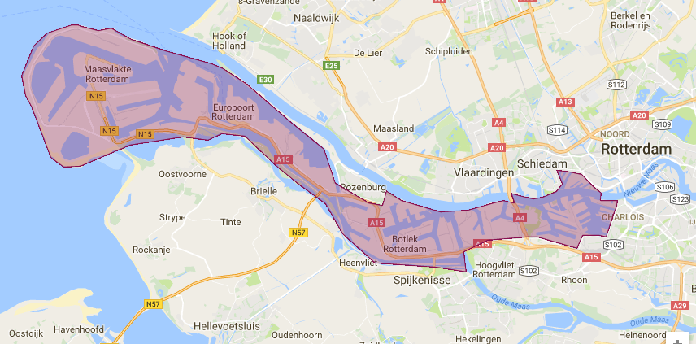
Source: own composition based on interviews
As seen in figure 18, HEBO strategically located oil spill response vessels to provide a fast intervention service. Moreover, through the contractual agreement, HEBO is obliged to have enough cleaning equipment to ensure the intervention, in parallel, to two oil spill calls.
        - Intervention equipment of Rijkswaterstaat
The responsibility for water quality of navigation ways in The Netherlands is held by the Minister of Infrastructure and the Environment. This responsibility is taken by RWS. Further, the water quality in The Netherlands was delegated to governmental and local authorities (provinces or even municipalities). For the water within the Port of Rotterdam, the cleaning and maintenance responsibility has been delegated to the RPA. Yet, RWS is still responsible for its quality, giving it the authority to control the actions taken by RPA. For example, when the RPA closes an oil spill cleaning contract with a private company, RWS has the authority to amend its content. Equally, in the eventuality of an oil spill event, representative of RWS can be involved in the intervention coordination center and contribute to the intervention coordination.
RWS takes the coordination of intervention for oil spill events that happen outside the port basin. RWS has a cleaning contract with the same cleaning company, HEBO. In the eventuality of an oil spill event on the main river, Maas, similar intervention equipment as in the case of the port of Rotterdam is used.
        - Intervention equipment of Schermenpool
Schermenpool (SRH) is an association of companies that takes care of the logistics, the maintenance and administration of oil protective equipment that exists in the port of Rotterdam. With the help from the fire brigade, they organize the transport and install the containment oil booms for a more effective oil spill intervention.
The equipment administrated by SRH consist of oil booms, aluminium racks used to transport the oil booms and oil screens as shown in table 10.
Table 10. SRH oil containment and cleaning equipment
Equipment
15 containers;
17 aluminium racks storage and transport of oil screens;
15 oil booms of a total 300 meters length (Lamor type FOB 750);
Two oil booms of 400 meters length (Elastec type FCB 90 II);
oil-arresting screen of 150 meters
Source: http://www.schermenpool.nl/materiaal.html
Furthermore, figure 19 present the launch location of these oil spills protective equipment.

Figure 19. Launch location of oil spill protective equipment managed by Schermenpool.
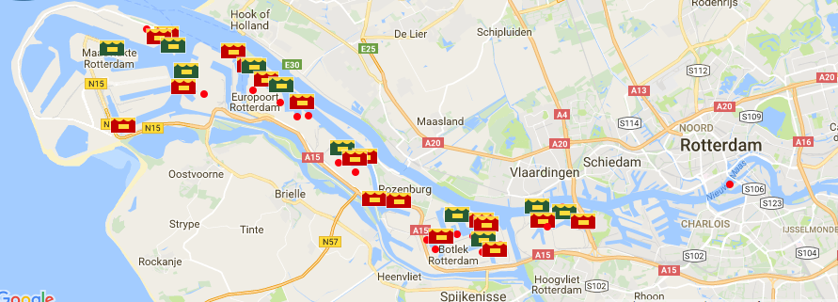
Legend:
Fixed location
Variable location
Association members
Source: http://www.schermenpool.nl/lanceerlocaties.html
From figure 19, it can be observed that SRH disposes of equipment located in the port of Rotterdam area. In the eventuality of an oil spill, this equipment can be used to cover the oil spill, to protect the area around the ships and to avoid for the spill to go in the sea or outside the basins.
        - Intervention equipment of the fire brigade
The special department of fire brigade (Gezamenlijke Brandweer) in the port of Rotterdam is a part of the Rotterdam-Rijnmond safety region. This department is a joint collaboration between about 65 companies in the port and industrial area of Rotterdam and the Municipality of Rotterdam. The organization provides the firefighting and rescue services. In special situations, they can intervene to help deploying oil booms and oil containment equipment in the port of Rotterdam. Moreover, in the eventuality of spills of gasoline, highly inflammable substances, and/or from the dangerous goods category the fire brigade is the only accredited organization to conduct the containment and cleaning operations. Figure 20 shows the location of GB’s barracks in the port of Rotterdam.
Within the area of Rotterdam port, the GB has 8 barracks with a 24/7 service.
Figure 20. Location of GB’s barracks in the port of Rotterdam.
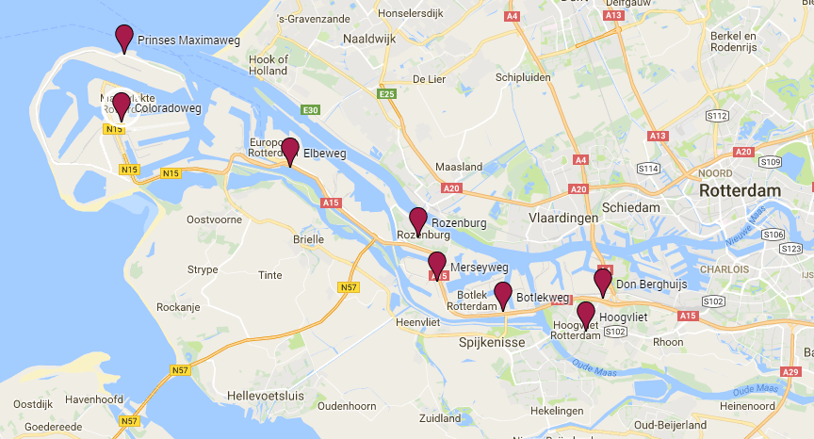
Source: http://www.brandweer.nl/rotterdam-rijnmond/organisatie/districten_en/kazernes_in_de_regio/
      - Level of preparedness (training / evaluation procedures)
This section discusses the training and the type of exercises that personnel involved in oil spill response need to follow. This is done from the perspective of personnel that responds to intervention on sea and in ports.
The officers that participate in intervention at sea benefit from a yearly training exercise. This exercise covers aspects such as SAR, ship collisions or oil spills. In case of oil spill exercises, the units use popcorn or biodegradable straws to simulate the spilt. Moreover, the intervention teams use computing tools which simulate the behaviour of oil spill in different conditions. These types of exercises are held minimum once a year.
For interventions that occur inland, the personnel follow a two days training course a year which goes over operative cleaning intervention issues. Moreover, the officers in charge are annually tested for general knowledge about intervention procedures.
All the exercises are evaluated by an external team. The intervention plans are then revised and updated procedures according to the outcome of the exercises.
Moreover, also within the review procedure, the national contingency plan follows every five years a major revision procedure based on a wide risk analysis.
In average, in The Netherlands, there are around 1200 oil spill events reported per year. About 10% of these reports require cleaning intervention or assistance from the specialized authorities.
The following paragraph discusses the training and exercises followed by intervention personnel to port calls. The officers in charge have to follow three times per year command centre trainings. These exercises are not specially focused on oil spills, but knowledge with regard to general emergency interventions such as SAR, fire on board of ships or ships collisions are given. The command centre structure of these events is applicable also in case of oil spills are reported. Moreover, the oil spill cleaning contractor has the task to organize and train its own personnel. These exercises are mandatory through the contractual agreement and the port authority has the power to regularly control if these contractual dispositions are respected.
After each training exercise, there is a debriefing of the exercise and some of the intervention plans are update. The officer in charge make a report with regard to the abilities tested in tested in each training. A copy of this report is then distributed and shared around the community.

Critical comparison of organization matters with regard to oil spills
This section discusses the organizational issues that appear when oil spills are reported in or around ports. The following problematics are put forward. Firstly, the oil spill notifications are compared. Secondly, the financial responsibility and oil spills cleaning costs recovery are address. A third point will be made will regard to oil spill prevention actions. Fourthly, the communication responsibility of authorities in case of oil spills reported in ports is debated. Finally, the equipment ownership and trainings for oil spill response are put forward.
The oil spill reporting means in European North-West European ports are put forward in the port regulation or port instruction document. Table 11 gives a comparative overview of the details contained in the oil spill reporting procedure. Key elements of the oil spill response structure are also compared.
Table 11. Comparison of oil spill notification/ response structure in ports
 | Port of Antwerp | Port of Rotterdam

Notification procedure

Phone, VHF, direct communication

To the PA/Harbour master

Location

Possible responsible party

Type of spill

Size
Oil spill frequency (small spills which require local intervention) | Once at 4-5 days | Once at 5 days

Oil spill response structure

On-site check for the accuracy of the report

Developed categories of spills and defines response actions

Officer in charge is 24h responsible

Contracted an oil spill cleaning company
Response time | 30 min | 1 h
Vessels on duty | 3 | 3 (to 5)
Source: own composition
Table 11 shows that no fundamental differences between the ports of A and R with regard to notification and response structure to oil spills. The notification procedure is put forward for the both cases by the port instruction document. This document indicates the means of communication can be used for oil spill notification. The following elements must be clarified in an oil spill report: the location, the possible responsible, the type of spill and the approximate size. Furthermore, the oil spill response follows as well the same structure in both European cases. The officer in charge verifies the accuracy of every oil spill and, based on predefined categories of oil spill, takes the intervention decision. The following paragraphs describe the financial responsibility and cleaning cost recovery procedure in the situation of oil spills.
Port authorities in Europe value the principle of “polluter pays”. The financial responsibility for all the negative effects produced by oil spills is put in the account of the polluting party. Table 12 compares the financial responsibility and cleaning costs recovery process in ports.

Table 12. Comparison of financial responsibility and cleaning costs recovery
 | Port of Antwerp | Port of Rotterdam

Financial responsibility and cleaning costs recovery

Polluter is responsible for all costs derived from the spill

PA intermediates the cleaning cost recovery

Cleaning company recovers cost directly from the polluter

Stand-by fee for the oil cleaning contractor
Source: own composition
As seen in table 12, few distinctions in the approach of cleaning cost recovery process exist in North-West European ports. The authorities in the port of Antwerp have an active role and intermediates the costs recovery process. The reason for this measure is to provide a fare and faster cost recovery scheme. This way the polluter benefits from the experience and the neutral position of the authorities with regards to cleaning costs. Equally, the cleaning company recuperates faster their cleaning expenses. Another difference is observed with regard to the stand by fee. This cost covers the expenses made with equipment maintenance and 24/7 personnel stand-by. The contractor in the port of Rotterdam case enjoys a fixed stand-by income, while in the port of Antwerp, the stand-by expenses are calculated in each intervention cost. The following paragraph accounts for the oil spill prevention actions.
Authorities and port users have understood that preventing an oil spill is more cost-efficient than accounting for its effects. Table 13 gives a comparative overview of prevention actions conducted by authorities in North-West European ports.
Table 13. Comparison of oil spill prevention actions
 | Port of Antwerp | Port of Rotterdam

Prevention actions

Actions initiated by the PA/Harbour master

Regular controls on boat

Patrolling for oil spill detection
Source: own composition
Table 13 shows that, although both port authorities initiate prevention actions to increase the awareness of oil spill effects among port users. This is done through regular presentations, press releases and controls on board of boats or vessels. Moreover, the port of Rotterdam authorities deploys also patrol vessels to constantly check for oil spills. An overview of the communication responsibility in the eventuality of on oil spill is given in the following paragraph.
Media communication is an important task in oil spill response actions. Table 14 puts forward a comparison between the communication aspects handled by authorities in oil spill response actions.

Table 14. Comparison of communication responsibility aspects.
 | Port of Antwerp | Port of Rotterdam

Communication
Communication responsible | PA | PA
Type of communication | Depends on the type and severity of the spill | Depends on the type and severity of the spill
Embedded procedures with regard to communication | Each spill is treated individually | Each spill is treated individually
Media releases for every oil spill | no | no
Source: own composition
The port authority being the responsible of water quality and the manager of port infrastructure, give communications with regard to intervention actions in case of oil spill. As shown in table 14, depending on the severity of an oil spill, public communications are made. Small oil spills that are handled locally, with own cleaning means are not reported via media. The level of preparedness to intervene in case of oil spill is further discussed from the perspective given by table 15.
Table 15. Comparison of level of preparedness.
 | Port of Antwerp | Port of Rotterdam

Owners of oil spill intervention equipment

Port Authority

Private contractor

Companies’ association

Public authorities

Training

Officer in charge, oil spill intervention personnel

Presence of external observers
Frequency of on water simulation training | Once per year (different each year) | Once per year (different each year)
Type of training exercises | On-water simulation, desk exercise | On-water simulation, desk exercise
Officer in charge training | IMO level 2 | IMO level 2
Source: own composition
Table 15 shows that the ownership of oil spill cleaning equipment, in both cases, is held by contracting companies. An association of oil terminals in the port of Rotterdam has opened a fund dedicated for the maintenance cost of extra oil booms that are strategically located in the port area. These oil booms are used in the eventuality that an oil spill occurs. Equally, for land oil spill interventions, public authorities in both ports own specialized cleaning equipment. Furthermore, the level of preparedness is compared from the perspective of trainings and exercises events also in table 15. With this regard, both ports dispose of specially trained personnel to intervene in case of oil spill. In both ports a major on-water training exercise is organized once a year. This exercise simulates different scenarios that involve the use of all the intervention and communication equipment.

Best-practices and lessons learned
This section shares bets-practices, lessons and advices to improve the oil spill response procedures in ports. These elements have been addressed in the last part of the interview as presented in Annex B – part B. The answers of oil spill experts have been centralized in table 16. Moreover, the analysis of the 2 cases leads to the 4 categories of lessons and best-practices. Although an effective oil spill response is based on a constant improvement process, oil spill experts gave advices with regard to communication, finance, training and planning issues.
Table 16. Lessons learned from the experience of oil spill response experts
 | Port of Antwerp | Port of Rotterdam
Communication
 | The report must be clear and as detailed as possible. | Always communicate with your partners.
 | The information communication is the strongest pillar in emergency situations.
 | Communication between parties needs to be concise. Communication is the key. The intervention team should act only within their area of expertise.
Finance
 | There has always to be a neutral party to verify/supervise the costs. | Pay attention to financial aspects.
 |  | Costs are not a barrier to intervene in case of life and wildlife SAR operations.
Training
 | Training of personnel is important should be done regularly. | Learn what are the effects of oil spill
 |  | Training is very important.
Oil spill response planning
 | All facts and figures must be reported. | Understand the area you work in.
 | Difficult to plan the interventions on two parallel oil spill calls. | Know how to use your equipment.
 | The results of cleaning procedure must be always checked.
Source: own compilation based on interviews
From the interviews, it is clear that the level of preparedness for oil response is based on an evolutionary process. The most lessons in oil spill are addressing communication and operative planning issues. Nonetheless, financial responsibility and thorough trainings are also important elements of an effective oil spill response. Furthermore, the optimal service lifetime of oil spill cleaning equipment is indicated in table 17.

Table 17. Lifetime of equipment used in oil spill response.
Equipment | Life time | Obs.
Floating booms | 5-7 years | Subject to yearly check-up and maintenance operations
Skimmers | Up to 10 years
Oil cleaning ships | 25 years
Source: own compilation based on interviews
As put forward in table 17, oil spill intervention experts indicated the optimal strategy for the renewal of oil spill intervention equipment. The average in-service time of intervention equipment is seven years. Nonetheless, depending on the usage conditions, this period can be extended. The floating booms have an expected in-service time of five to seven years and the oil skimmers can be used for ten years. The oil spill cleaning ships have a life expectancy of 25 years.
After discussing the lessons learned during oil spill intervention, this sections outlines aspects of spill response that can often be improved. Table 18 summarises the best-practises given by the professionals in oil spill response. The same distinction between communication, finance, training and planning issues is made.
Table 18. Best-practices to improve the oil spill response.
 | Port of Antwerp | Port of Rotterdam
Communication
 | Communicate short and clear. | Double check of information in the first notification.
Finance
 | Have always enough experienced personnel and finance. | Invest in personnel and equipment periodically.
Training
 | Train regularly and disseminate the learning process to others. | Allocate enough budget for training exercises.
Oil spill response planning
 | Limit the number of people that participate in the decision groups in case of emergency action/interventions. | Increase the awareness level over the effect and damage produced by oil spills.
 | Follow a strict regulatory framework with regard to oil spill cleaning standards still has to be developed. | Involve the contribution of environmental agencies or wild life protection agencies.
 | Keep a good status of the intervention vessels. | Own good tools (vessels) to localize the oil spills.
Source: own compilation based on interviews
Best-practices to improve the oil spill response have been put forward in table 18. Experts in oil spill intervention have pointed out that response planning still can be improved. With this regard, only a limited number of persons should lead the intervention operations. Equally, a good regulatory framework and enough oil spill detecting equipment is also key in oil spill interventions. With regard to finance and training, enough budged will always increase the intervention and training quality of personnel. From a communication perspective, the personnel involved in oil spill notification should have the duty to ask short precise information and to always double check the received notification. Lastly, the involvement of environmental agencies in planning is also important. However at operational level there is always a positive feedback from the environmental organizations, on strategic level, this organisation always make pressure for the cleaning job to be done correctly.

Final conclusions/recommendations
Environmental awareness is a must of contemporary activities. Ports are confronted with pollution sources such as waste, plastics, emissions and oil spill. Both public and private enterprises are making efforts to reduce the impact of transport activity on the environment, yet accidental polluting releases still happen. With regards to oil spills, communication, cooperation and fast intervention are key to effective intervention. This report by conducting desk research and interviews with specialists in oil spill response, studies in-depth the intervention procedures, lessons and best-practices in ports of North-West Europe.
The most important findings of this research are as follows:
- Regional agreements with regard to pollution on sea exist at country level. In Europe, EU is contracting party at these agreements;
- The Bonn agreement, signed by the North sea countries is the main collaboration instrument to offer mutual aid that refers to maritime disasters and chronic pollution from ships and offshore installations;
- Each country has developed its own intervention plan which applies in case of emergency/oil spill response;
- At port level, port authorities have the responsibility to organize own oil spill response procedures respecting the national emergency response procedures;
- The practice of North-West European ports, shows that port authorities give preference to externalization of cleaning operations to private companies;
- There are no significant differences in the notification and oil spill response procedure in ports of North-West Europe;
- Port authorities practice is to charge the oil spill cleaning cost on the polluter’s account;
- Port authorities have a key role in prevention and managing the oil spills;
- Communication in the eventuality of an oil spill is done the PR of the responsible authorities in ports the port authority;
- Training is key of having a good preparedness level for oil spill intervention; yearly trainings are organized for intervention teams in ports of North-West Europe.
This research is relevant for industry as well for policy makers. The presented case studies, results and interpretation represent a basic foundation on which decisions with regard to oil spill planning can be made. Nonetheless, further research is required to validate the findings from this study more in depth. The expansion of case studies to other geographical regions, may offer more interesting result. Moreover, scientific research did not address the topic of oil spill response from the perspective of public satisfaction. Equally researchers might pursue the calculation of cost-effectiveness of prevention actions between the actual cleaning or ex-post negative effects costs.

Acknowledgement
The authors wish to thank to oil spill experts for participating in our interviews and for sharing their professional experience. The list of experts, their affiliation and function is presented in Annex A. The authors also wish to thank to ClearSeas for financing this research.

Reference list
Bergueiro, J. R., March, R. R., González, S. G., & Socías, F. S. (2007). Simulation of oil spills at the Casablanca platform (Tarragona, Spain) under different environmental conditions. Journal of Maritime Research, 3(1), 55–71.
Bergueiro, J. R., Oliver, A. S., González, S. G., & García, S. M. (2007). Contingency plan for hydrocarbon spills in the port of Ibiza. Journal of Maritime Research, 4(1), 51–62.
Bonn Agreement | Working Together For Cleaner Seas. (n.d.). Retrieved September 5, 2016, from http://www.bonnagreement.org/
EMSA. (2016). Inventory of EU Member States Oil Pollution Response Vessels 2016. Retrieved from http://www.emsa.europa.eu/news-a-press-centre/external-news/item/2777-inventory-of-eu-member-states-oil-pollution-response-vessels-2016.html
EMSA. (n.d.). Technical cooperation in pollution preparedness and response - International Forums - EMSA - European Maritime Safety Agency. Retrieved October 14, 2016, from http://www.emsa.europa.eu/technical-ppr/international-forums.html
GREEN4SEA, G. (2015, March 13). EMSA contracted vessels protecting seas against oil pollution. Retrieved from http://www.green4sea.com/emsa-contracted-vessels-protecting-seas-against-oil-pollution/
IMO. (n.d.-a). List of Conventions. Retrieved October 14, 2016, from http://www.imo.org/en/About/Conventions/ListOfConventions/Pages/Default.aspx
IMO. (n.d.-b). Oil Spill Response. Retrieved October 14, 2016, from http://www.imo.org/en/OurWork/Environment/PollutionResponse/Inventory%20of%20information/Pages/Oil-Spill-Response.aspx
Noordzeeloket | Government of The Netherlands | Maritime zones in the North Sea. (n.d.). Retrieved September 30, 2016, from https://www.noordzeeloket.nl/en/spatial-management/maritime-zones/
OPRC. (n.d.). International Convention on Oil Pollution Preparedness, Response and Co-operation. Retrieved October 14, 2016, from http://www.imo.org/en/About/Conventions/ListOfConventions/Pages/International-Convention-on-Oil-Pollution-Preparedness,-Response-and-Co-operation-(OPRC).aspx
Statistics - ITOPF. (n.d.). Retrieved July 5, 2016, from http://www.itopf.com/knowledge-resources/data-statistics/statistics/
Werkingsgebied | Kustwacht. (n.d.). Retrieved October 1, 2016, from http://kustwacht.be/nl/inhoud/werkingsgebied

ANNEX A. List of experts interviewed
 | Name | Surname | Organization | Position/Function | Type of interview
Belgium
 | Vanderhallen | Joris | Port Authority | Senior technisch manager milieu | Personal interview
 | De Craene | Kris | Port Authority | Manager Ruimtelijke ordening & milieu | Personal interview
 | Bosseler | Marc | Harbour master | Harbour master | Personal interview
 | De Pauw | Peter | Harbour master | Nautical Coordinator | Personal interview
 | Hendrikx | Robert | Harbour master | Assistant Chemist | Personal interview
 | Haex | Christel | IBZ | Federale Diensten Gouverneur Antwerpen - Dienst Noodplanning | Personal interview
 | Martens | Anne | IBZ | Federale Diensten Gouverneur WestVlaanderen - Dienst Noodplanning | Personal interview
 | Van Eeckhoven | Peter | Scheepwart politie | Posthoofd Watergebonden Politiezorg | Personal interview
 | D'Hooghe | René | Civil protection | Operationeel deskundige | Personal interview
 | De Groof | Koen | Brabo cleaning company | Commercial Manager | Personal interview
 | De Brabandere | Jef | Group de Cloedt | Business Manager | Personal interview
 | Bruelemans | Bart | Antwerp municipality | Emergency manager | Personal interview
 | Lemmens | Wilfried | Ship owners association | Afgevaardigd Bestuurder | Personal interview
The Netherlands
 | Schrot | Rob | Harbour master | Officer in Charge | Personal interview
 | Wensveen | Marco | Havenbedrijf Rotterdam | Asset Manager | Personal interview
 | Huisman | Sjon | Rijkswaterstaat Zee & Delta | Senior Nautisch Adviseur | Skype interview
 | Van Geyte | Erwin | AON | Broking Director | Personal interview
 | Soekar | Oemesh | Schermenpool Rotterdams Havengebied | Gezamenlijke Brandweer - General Secretariaat | Telephone call
 | Van der Meer | Mark | HEBO | Manager OSRT | Telephone call
Germany
 | Winkler | Gudrun | Behörde für Umwelt und Energie | Freie und Hansestadt Hamburg | Personal interview
 | Maudrich | Sven | Hamburg Port Authority | Hochwasserschutz und Gefahrenabwehr | Personal interview

ANNEX B. Survey
Oil spill response and preparedness in ports
Survey Guide

We kindly invite you to participate in our survey with regards to your organization’s experience in oil spill response. No name, position or affiliation of interviewees will be included in our report.
This survey is part of a project of the Centre for Transportation Studies at the University of British Columbia, Vancouver, Canada in collaboration with universities in Antwerp and Hamburg. The project is an examination of leading systems in ports for response to oil spills.
The goal of this stage of the project is to describe the spill response practices in leading ports.
The purposes of our interviews are:
- To clarify the plans, roles, activities and processes of organisations involved in response to oil spills in ports.
- To identify strategies, challenges and opportunities to maintain and to advance the effectiveness of spill response
The survey follows an open question structure and is clustered in 2 categories. Questions in section A enquire about the role and the processes of your organization with regards to oil spill response plans and preparedness. It deals with the wide range of activities which may be required in the event of an oil spill. Questions in section B request information related to maintaining and advancing effective spill response.
In the final report, interview comments will be grouped according to geographic jurisdiction. No names or affiliations of interviewees will be provided unless you direct us to do so.
The following questions identify specific matters of interest. They are grouped into topic areas to facilitate discussion.
A. Plans and Preparedness
A.1 Response plan.
- Do you have an oil spill response plan?
  - If yes, when was it last updated?
  - Are there regulatory requirements for spill response plans and, if so, are plan contents clearly specified?
  - Is there a process by which plans are reviewed and, if so, by whom?
- What organizational structure does your plan, or emergency response, follow: ICS/UC (Incident Command System/Unified Command) or another?
  - Why was it selected?
- How does your team integrate with other parties in the response processes? If other groups are involved, who is in charge? How is the command structure defined and communicated to all involved?
- Does the plan include a record, list, or maps of environmentally sensitive areas and protection priorities?
- Has a strategy for protecting and cleaning various areas been developed and agreed?
- Do you measure/take into account the public satisfaction of for your oil spill prevention/information/cleaning activity?
- Does your country have a national contingency plan with regards to oil spill response?

A.2 The significance of a spill.
- Who defines the “significance/scale’ of a spill? What language is used to define those scales (i.e. level 1, 2, 3; tier 1, 2, 3 other)
  - Has the organization developed defining criteria for these levels of spill?
  - Are there processes in place for assessment of the scale of a spill and of resources (places) most at risk?
- What is your role depending on the ‘scale’ of a spill?
A.3 Organizational matters
- Have specific emergency responsibilities been identified for the on-site/tactical response?
  - How well would you say people understand their role and responsibility in the event of an emergency?
- Does your plan include pre-approved statements that can be released to “hold” media & others for a short time?
  - How is media communication monitored, particularly online discussions?
  - Is there a prescribed process for review and approval of public releases on incident information?
- Does your plan identify stakeholders within the potentially affected community?
  - Is there a plan in place to monitor/liaise with advocacy groups and the impacted community?
  - Who manages communications/stakeholder engagement?
- How do you plan for the availability of physical and human resources, e.g.:
  - The availability of a command centre.
  - The inventory of spill containment, collection, dispersants, waste handling, shoreline clean-up, and oiled wildlife treatment systems.
  - What are the criteria and process by which the inventory levels are set?
  - What methods are used to ensure the availability of well-informed and connected people (goes beyond training)?
- Have waste storage sites and final disposal plans been identified or prepared?
- Have mutual aid arrangements been made to share response resources within your port, on a national and on an international level? Is response readily scalable?
- How do you deal with community expectations?
A.4 Operational matters.
- Who makes the decision to mobilize emergency response?
- Are time standards defined for the deployment of specific amounts and types of containment and other resources? What process/criteria were used to set the standards?
- Please describe the process/timeline for decisions to mobilize emergency response.
- Incident notification and call-out process – is it direct to the key individuals? How do you/who maintain/s the call out list?
  - How are incident/emergency notifications made? (by phone, pager, SMS/text sent at once?)
  - Is there a specific spill report form used by, or required for, the Port?

A.5 Financial matters
- Do you have a funding mechanism in place that enables you and/or others in the port to respond immediately?
  - If so, how does it work?
- Is there a spending cap or approval mechanism in place and how is that administered?
Can cost recovery uncertainty affect spill response? How do you manage this?
- Please tell us about your approach to:
  - Tracking spill response costs (process and practice)
  - To cost recovery (process and time frame)
    - What would happen if the responsible party exceeded the limits of their legal liability?
    - Does your organization account for the cost-effectiveness of cleaning operations?
A.6 Your opinions (your views are kept confidential)
- How well do you feel the various areas listed below integrate with one another? Within your organization? Within the spill response community?
  - Emergency/incident notifications
  - Response/activation process
  - Response management both on shore and on site
  - Business continuation
  - Post crisis requirements
    - Root cause analysis
    - cost recovery
    - legal issues/findings
    - incident, response and process improvement
    - debrief with key stakeholders: response organizations, customer and other industry representatives
- How well do you feel your current plan assesses third party risks – i.e. incidents which are not the responsibility of your organization but which have the potential to require response assistance or damage your reputation via implied or implicit relationships?
B. Training, exercises and lessons
- What sorts of training is provided for your team members?
  - Training for on-site/tactical response?
  - Is media training provided?
  - What about training for telephone responders?
- How does your organization pursue effective spill response relationships and collaboration with the other involved parties (terminals, shippers, etc.) for preparedness/planning? Are you confident that all organisations are aware of and can meet their obligations?
- Do you conduct . . . (if yes, how often?)
  - On the water simulations with equipment deployment?
  - Command centre scenario-based training?
  - Inter-agency exercises, national and international? If yes, who is involved?
  - Other?
- Are there established procedures for review and learning from exercises?
- Do you keep a history of oil spills and reports on them? Can you provide data on oil spills reported in the port of Rotterdam over the last five years (date, amount spilled, oil type, etc.)?

- What worked well and what lessons were learned in the case of a recent spill involving your organisation?
- Do you see ways to improve your organization’s level of preparedness in case of oil spills? Is research by your organisation or others a part of your improvement strategy?

http://www.ospar.org/
http://www.bonnagreement.org/be-aware
http://www.bonnagreement.org/site/assets/files/1081/bonn_agreement_counter_pollution_manual.pdf
Koninklijk Besluit (Royal decree) – Emergency and intervention planning
http://www.rijkswaterstaat.nl/english/index.aspx
https://english.nctv.nl/binaries/j-18732-web-eng-wet-veiligheidsregios_tcm32-84093.pdf
https://www.gezamenlijke-brandweer.nl/SitePages/Introductiepagina.aspx

